UNLEASH THE POWER WITHIN

#### | 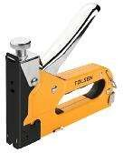 | BAM KIM CONG NGHIEP  - "GS chap thuan  - Dfii vñi kim bfim day manh 0,7mm  - Chiéu dai chan ghim: 4-14mm (5/32 "" - 9/16 "")  - Nut nha mut nhanh  - Oieu chinh cong suat tac dong  - Bé mat: Son hoan thién | 43020 |  | 1s5.000 | 10% | 140.000
 | 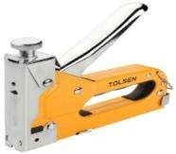 | BAN KIM (CONG NGHI;EP)  - Size 4-14i in  - Co san 200 kim : vuong inien, hinh chit U, inong tay. | 43021 | 6/24 | 153.000 | 10% | 138.000
#### | 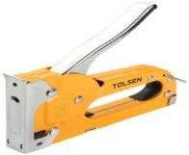 | BAN KI M  - Kich thuñc: 4-8mm (5/32 "-5/16")  - Bé mat: sun phii | 43022 | 10/40 | 97 000 | 10% | 87.000
 | 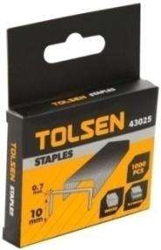 | HOP 1.000 KIM 0.7x6mm  l000pcs | 43023 | 0/200 | 8.000 | 10% | 7.000
#### |  | HOP 1.000 KIM 0.7x8mm  l000pcs | 43024 | 0/200 | 9.000 | 10% | 8.000
#### |  | HOP 1.000 KIM 0.7x10mm  l000pcs | 43025 | 0/200 | 10.000 | 10% | 9.000
#### |  | HOP 1.000 KIM 1.2x8mm | 43028 | 0/100 | 15 000 | 10% | 14.000
 |  | HOP 1.000 KIM 1.2x10mm | 43029 | 0/100 | 16.000 | 10% | 14.000
#### |  | HOP 1.000 KIM 1.2x12mm  l000pcs | 43030 | 0/100 | 16.000 | 10% | 14.000
 | 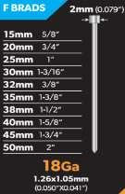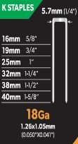  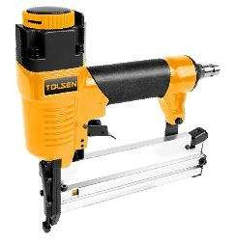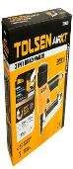 | SUNG BAN DINH HDI 2 TRONG 1 ( CONG  NGHIEP )  - "CE phé duyét  - Thich hop cho brads:  - F brads 18Ga. 1,26 * 1,05mm: 10-50mm (5/8 "" - 2 "")  - K brads 18Ga. 1,26 * 1,05mm: 13-40mm (5/8 "" - 1 -5 / 8 "")  - Dung lupng tap chi: 100 chiéc  - Ap suat hoat dong: 70psi (0,5Mpa) -1 l0psi (0,75Mpa)  - Khi vâo: 1/4 ""  - Khoi litpng tinh: l,3kg  - Dac trung  - Ong xâ dieu chinh 360 °  - Do sâu co the diéu chinh  - Oau No-mar bao ve be meat lam viec  - Chi bao tai lai  - Phu kién  - 300 chiéc F brads • Kim barn K 300 chiéc  - Phim luc giac 2 car • 1 car not dau  - Bo ghép noi nhanh 3 car vñi ski diic 1/4 "" PT  - Dñng gfii: hñp mñu "  - Bao hânh: 6 thang  - Dfii mii: 7 ngay theo diéu kien | 73420 |  | 728.000 | 15% | 619.000
#### | 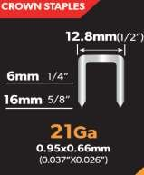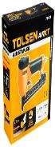  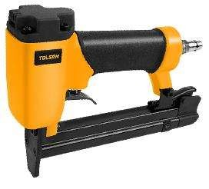 | BAM KIM HHI ( CONG NGHIEP )  - "CE phé duyet  - Thich hop cho mñt hang chu Inc:  - Kim bfim vuong mien 21Ga. 0,95 * 0,66mm: 6- 1 6mm  - Dung ltrpng tdp chi: 120pcs  - Ap suat hoat dong: 60psi (0,4Mpa) - l00psi (0,7Mpa)  - Khi vao: 1/4 ""  - Khoi loong tinh: 0,8kg  - Ly tuong de bpc, lap rap tu, san xuat do noi that  - Phu kién  - 300 chiéc kiin barn vuong mien  - Phim luc giac 2 cai  - 1 cai nñi dau  - Bo ghép noi nhanh 3 cai vñi soi duc 1/4 "" PT  - Dong got: hñp inau "  - Bao hânh: 6 thang  - Dñi mii: 7 ngay theo diéu kién | 73425 |  | 652.000 | 15% | 554.000
#### | 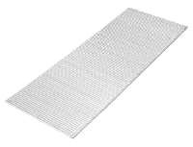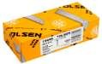 | DING F SUNG HO'1 25MM  - "25mm  - I SGA, 1,25xl,Omm  - Dau dinh: 2x l,25mm  - Bé mat ma kem  - Dong got: 5000 chiéc trong infit hfip man " | 73443 |  | 59.000 | 10% | 53.000
 |  | DI NG F SUNG H€fI 30MM  - "30mm  - 18GA, 1,25xl,Omm  - Dau dinh: 2xl,25mm  - Be iliat ma kém  - Ofing goi: 5000 chiéc trong not hop mau " | 73444 |  | 68.000 | 10% | 61.000
#### |  | DI NG F SUNG HDI 32MM  - "25mm  - 18GA, l,25x l,0mm  - Dau dinh: 2xl,25mm  - Bé mat ma kem  - Dong gfii: 5000 chiéc trong mot hop mau " | 73445 |  | 71.000 | 10% | 64.000
 |  | DING F SUNG HDI 40MM  - "40mm  - 18GA, l,25xl,Omm  - Dau dinh: 2x l,25mm  - Be mat ma kém  - Ofing goi: 5000 chiéc trong mot hop mau " | 73448 |  | 88.000 | 10% | 79.000
 |  | DING F SUNG HDI SOMM  - "50mm  - 18GA, 1,25xl,Omm  - Oau dinh: 2x l,25mm  - Bé mat ma kém  - Ofing gfii: 5000 chiéc trong mot hop mau " | 73449 |  | 108.000 | 10% | 97.000
 | 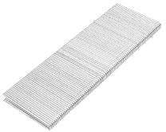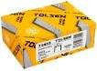 | KI M BAM SUNG HOI 25MM  - "25mm  - 18Ga, 1,25x l,0mm  - Vuong mién ghim: 5,7mm  - Bé mat ma kém  - Dong got: 5000 chiéc trong mot hop man " | 73455 |  | 113.000 | 10% | I 02.000
 |  | KIM BAM SUNG HOW 30MM  - "30mm  - I 8Ga, 1,25x l,0mm  - Vuong mien ghim: 5,7mm  - Bé mat ma kém  - Dfing goi: 5000 chiéc trong mot hñp mau " | 73456 |  | 132.000 | 10% | 119.000
 |  | KIM BAM SUNG HD1 35MM  - "35mm  - lSGa, 1,25x1,Omm  - Vuong mién ghim: 5,7mm  - Bé mat ma kem  - Dfing gfii: 5000 chiéc trong mot hop man " | 73457 |  | 154.000 | 10% | 139.000
 |  | KIM BAM SUNG H€fI 40MM  - "40mm  - 18Ga, 1,25xl,Omm  - Vuong mien ghim: 5,7mm  - Bé mat ma kém  - Dong goi: 5000 chiéc trong mot hñp mau " | 73459 |  | 172.000 | 10% | 155.000
 | 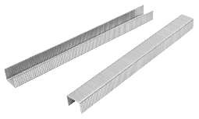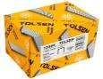 | KIM BAM SUNG HDI 10MM  - "10mm  - 21Ga, 0.9x0,65mm  - Vuong mien ghim: l2,7mm  - Bé mat ma kem  - Dñng gfii: 10000 chiéc trong inot hop mau " | 73462 |  | 69.000 | 10% | 62.000
 |  | KIM BAM SUNG HDI 12MM  - "l2inin  - 21Ga, 0.9x0,65mm  - Vuong mien ghim: 12,7mm  - Bé mat ma kem  - Dong got: 10000 chiéc trong mfit hfip man " | 73463 |  | 77 000 | 10% | 69.000
 |  | KI M BAM SUNG HDI 14MM  - "14mm  - 21Ga, 0.9x0,65mm  - Vuong mien ghim: 12,7mm  - Bé mat ma kem  - Dong gfii: 10000 chiéc trong mot hop mau " | 73464 |  | 85.000 | 10% | 77.000
 |  | KI M BAM SUNG HDI l 6MM  - "16mm  - 21Ga, 0.9x0,65mm  - Vitong mien ghim: 12,7mm  - Be mat ma kém  - Ofing goi: 10000 chiéc trong mot hñp mau " | 73465 |  | 94.000 | 10% | 85.000

