TCXDVN VIETNAM CONSTRUCTION STANDARD

TCVN 296: 2004

STEEL SCAFFOLDING

SAFETY REQUIREMENTS

Construction Publishing House
TCXDVN VIETNAM CONSTRUCTION STANDARD

TCVN 296: 2004

STEEL SCAFFOLDING

SAFETY REQUIREMENTS

Construction Publishing House
Hanoi - 2004

FOREWORD

TCVN 296: 2004 “Scaffolding – Safety Requirements” was prepared by the Architectural Research Institute upon the request of The Bureau of Science and Technology – Ministry of Construction and promulgated by the Ministry of Construction according to Decision No 01/2004/QÑ-BXD dated 14th February 2004
VIETNAM CONSTRUCTION STANDARD TCXDVN 296:2004

Steel Scaffolding - Safety Requirements [Compulsory]

- Scope of application

This standard provides safety requirements upon assembly, erection, use, maintenance, disassembly of scaffolding used in constructing, repairing, destructing buildings and works.

This standard applies not to continuing suspended scaffolding systems or overhead suspended working floors.

- References

  - Vietnam Construction Standards, Chapter 17;
  - TCVN 5308: 1991 Safety Technical Regulations in Construction;
  - TCVN 6052: 1995 Steel Scaffolding

- Terms – Concept

3.1 Ready manufactured scaffolding: Ready manufactured working floor table type with hooks closely connected to Diagonal bar of scaffolding;

3.2 Scaffolding: Temporary structural system lays on firm floor or can be suspended, anchored or leaned against works for working at high positions from the ground or fixed floor.

3.3 Pillar scaffolding and mobile Cantilever stand: Scaffolding with pillar, floor plank and floor stand can be removed on the pillar.

3.4 Cantilever beam scaffolding: Scaffolding with working floor lays upon Cantilever beams from wall or on floor surface. Inside head is firmly anchored into the work or any structure.

3.5 Suspended beam scaffolding: Working floor lays upon two beams suspended by cables.

3.6 Squared leg scaffolding: Scaffolding with supports made by square wood, above to support working floors with light and medium loads.

3.7 Independent pillar scaffolding: Scaffolding lays upon floor by several pillar columns. This type of scaffolding stands independently, not lean on work including pillars, longitudinal beams, restrained beams and cross beams.

3.8 Single pillar scaffolding: Working floor lays on restrained beams with outside head placing upon longitudinal beams connected to pillar column or single pillar. Inside head of beam anchored onto the inside or on wall.

3.9 Square-rule typed supporting frame scaffolding: Scaffolding includes wood or iron frames supporting the working floor.

3.10 Cantilever ladder typed scaffolding: Scaffolding for light load; working floor placed upon cantilever beams connecting with independent ladders or be prolonged.

3.11 Hand-push typed mobile scaffolding: Scaffolding placed on wheels and only be moved when pushed or pulled.

3.12 Ready made steel frame scaffolding: System of iron pipe frames [Scaffolding leg] assembled together by beams.

3.13 Horse foot typed scaffolding: Scaffolding for light or medium load, including trestle leg supporting the working floor.

3.14 Scaffolding and unit of steel scaffolding and joints: Scaffolding system made from steel pipe bars such as pillars, longitudinal bars, restrained bars and Diagonal bar with plates supporting the bars and particular joints to connect pillars and other bars.

3.15 Indirect suspended/hooked scaffolding: Working floor placed and hooked into two cables suspended in parallel horizontally; heads of wires closely connected to the work.

3.16 Multi-point suspended scaffolding: Scaffolding supported by several cables from upper supporting units and assembled, operated upon lifting/downing working floor to desired positions.

3.17 Multi-floored suspended scaffolding: Scaffolding with working floor at different height levels placed within a supporting system. This system can be hung from one or several points.

3.18 Safety belt: Soft belt tied to the human back or labor equipments with retaining end connected into fixed point or safeguard belt.

3.19 Safeguard belt [Emergency or rescue belt]: Vertical belt from a fixed anchor independently from the working floor and anchor wires used for hanging or hooking safety belts.

3.20 Hip [back] belt: particular tool tied to body used for retaining or rescuing when working or in dangerous areas.

3.21 Working floor unit: Smallest working floor can independently operate or assembled into larger working floor. Working floor unit can be made from special board, scaffolding plates or iron ready made floor.

3.22 Handrail: Protective bars assembled along with open surfaces and end parts of working floor, including upper bars [banister], medium bars and pillars.

3.23 Safety curtain: Protective curtain placed between banister and foot protective bar to prevent any tools or material falling from the scaffolding.

3.24 Scaffolding foundation: Solid ground or floor of building floor and works.

3.25 Anchor: Joining parts between the scaffolding and working floor or structure to improve the stability from 2 side of the scaffolding.

3.26 Rear/back anchor: Connecting from the work or structure with lifting equipment.

3.27 Working floor: Floor for worker vertical and arranging materials at needed positions, made from one or several working floor unit(s).

3.28 Working load: Load including persons, materials and equipments on the scaffolding.

3.29 Max load: Total load of scaffolding, people, equipment, tool, material and other impacts to the scaffolding.

3.30 Cross bar: Part fixing the scaffolding and connecting with other parts.

3.31 Lifting equipment: Equipment used for lifting or downing any suspended scaffolding system. It can operate manually or automatically [machine].

3.32 Board or ready made floor: Plane working surface made from wood, iron or new material structure in solid or holed.

- General requirements for all types of scaffoldings

4.1 General parts
4.1.1 Scaffoldings used in construction must ensure requirements on design, structure, assembly, operation, disassembly provided in technical document and record of the manufacturer. Not permit to install, use or disassemble the scaffolding if lack any above documents.

4.1.2 Parts used for installing the scaffolding must comply with technical document and any other stipulations of this standard, ensuring requirements of intensity, size and weight. Scaffolding must be designed and assembled according to safety force bearing as designed.

4.1.3 Person in charged of assembling and disassembling the scaffolding must be gone through training course and comply with process requirements as well as being equipped with labor protective equipments.

4.1.4 Not use the scaffolding in the following cases:
[a] Qualify not technical requirements and working safety conditions provided in design document or record of the manufacturer;

[b] Not correspond to functions of work category;

[c] Any parts of the scaffolding with deformation, crack, corrosion or rust;

[d] Distance from working limit of the scaffolding, support to the next edge of transportation means < 0.60m;

[e] Pillars or leg frames of the scaffolding lay upon unstable foundation [weak ground, unqualified water drain, sink to over permitted limit…], slippery, breakable or placed upon parts or structures of buildings that not warrant the stable force bearing capacity for parts, structures, pillars, supporting frame of the scaffolding.

4.1.5 Put no overload on the scaffolding. If use of ready made scaffolding, follow up instructions of the manufacturer.

4.1.6 Not permit the scaffolding moving to other sides or change structure of the scaffolding when in use, except scaffoldings particularly designed for those purposes.

4.1.7 Not to install, disassemble or work on scaffolding under bad weather conditions such as heavy rain, strong wind from grade 5 and above.

4.1.8 Scaffolding and its components must not be used in corrosive chemical locations and to ensure appropriate protective measures from damage according to the manufacturer’s guide.

4.1.9 Disassembling of the scaffolding must comply with the manufacturer’s guide and begin from its top:

- Disconnected parts and joints must be safety lowed down, let not falling down freely. Ensure to retain the stability of un-dissemble parts till the completion;
- Within the disassembling area must have protection fence, prohibited signal from any passing. Never disassembling the scaffolding by pulling down.

4.1.10 When installing, using or disassembling scaffolding that near electric wire [under 5m, including the low voltage wire] must ensure electric safety method for in charged persons and must be approved in advance by the electric management [disconnect the electric while installing…].

4.2 Supporting system of scaffolding

4.2.1 Leg of scaffoldings must be firm and ensure max loading capacity as design. Nondurable parts such as wood box, carton box, brickbat are not permitted to use as supporting leg of scaffoldings.

4.2.2 Pillars, leg or vertical bar of scaffolding must be installed straightly as well as connected firmly with foundation to prevent from rotation or movement.

4.2.3 When use of rope, synthetic or steel cable in works with erosive gases or chemicals must ensure preventive methods from these effects.

4.2.4 All cables used for suspending the scaffolding must have capacity to bear a force at min 6 times higher than the designed load.

4.3 Load requirements

4.3.1 Scaffolding must be able to bear force without being destructed by itself load and at min 4 times higher than the calculated load. For the safety handrail, suspending cable and wood structures are applied according to specific requirements.
4.3.2 Loading level: Max loads must be categorized as follow:

- Heavy load: Applies for scaffolding carrying working load = 375 kG/m² used for constructing brick, stone as well as materials placed upon the working floor;
- Medium load: Applies for scaffolding carrying working load = 250 kG/m² used for persons and working equipments;
- Light load: Applies for scaffolding carrying particular load and accompanied materials.

4.3.3 Categorization of load according to working floor

4.3.3.1 Load requirement for people: Designed load for working floor is calculated upon basis of one or more than one person with weight = 75kg and 25 kg equipment per person. Each working floor unit must ensure to lift one person according to following stipulation:

[a] Working floor for one person is designed and installed for load = 100kg placed in the middle of floor;

[b] Working floor for two persons is designed and installed for load = 200kg, in which 100 kg placed within 0.45m toward the left and another 100kg placed within 0.45m toward the right of the straight in the middle of floor;

[c] Working floor for three persons is designed and installed for load = 300kg, in which 100 kg placed within 0.45m toward the left, 100 kg in the middle and another 100kg placed within 0.45m toward the right of the straight in the middle of floor;

4.4 Requirements of the working floor [Figure 1.7, Appendix B]

4.4.1 Working floor must be stable and ensure the calculated load. Materials selected in making the floor must ensure intensity and comply with actual requirements; be able to prevent from chemical erosion and atmosphere.

Note –Board and ready made working floors including wood frame board, scaffolding board and shaped beam floor.

4.4.2 Working floor [except once being firmly connected or anchored] must ensure the length exceed the restrained bar from both ends a distance not < 0.15m and not > 0.5m.

4.4.3 Wood board:

[a] Wood board must be designed so that the sagging in the middle according to the designed load not exceed 1/60 span per scaffolding;

[b] Max span of wood board is provided according to the design and the manufacturer basing on reliable calculation for wood floor;

[c] Wood board should be used in dry area and well-ventilated. If the board is fresh or under humid condition the calculation of stress and check thus must consider the wood humidity.

4.4.4 Ready made scaffolding, board and floor includes following types: Ready made board, framed wood board, beamed wood board and shaped beam floor.

4.4.4.1 Ready made scaffolding: Min width of scaffolding not < 0.3m; standard length from 1.8m-3.0m.

4.4.4.2 Length and width of ready made boards and working floors is provided in Table 1.

Table 1. Specification, calculated load of ready made board and working floor

Ready made product | Calculated load  [kG] | Length  [m] | Max width  [m] | Min width  [m]
Framed wood board | 110 | 7.2 | 0.5 | 0.3
Scaffolding board | 220 | 9.6 | 0.5 | 0.3
Board with beam | 220 | 12.0 | 0.75 | 0.5
Shaped beam floor | 330 | 12.0 | 0.90 | 0.5

Note – Table 1 applies not to the scaffolding table

4.4.5 Each ready made scaffolding table must have anchoring hooks and allow scaffolding table placed fit to the supporting parts of the scaffolding. Anchoring hooks must ensure to keep the scaffolding table from being lifted up.

4.4.6 Types of scaffolding: Solid or mesh types. Surface of scaffolding table must be firmly kept with the edged blocking bars or crossing restrained bars.

[a] The open of scaffolding table: Max open between the scaffolding table with each edged blocking bar and between boards must not exceed 1cm;

[b] Surface of scaffolding table: Can be placed lower than the upper surface of the edged blocking bar. Surface of the iron scaffolding table must ensure measure to prevent from slippery.

4.5 Requirements of safety handrail

4.5.1 Protective handrails must be assembled from both the opened side and at the end of the working floor with height > 3.0m compared with building floor, except the following:

[a] When assembling or disassembling scaffolding;

[b] When the scaffolding placed indoor where protected from sides by walls without any opened sides such as staircase or elevator;

[c] When use of protective belts and safety belts for people [for suspended scaffolding, chairs or ladder typed scaffolding];

[d] When use of vertical typed ladder supporting the scaffolding.

4.5.2 Banister must have its height from 0.8m to 1.15m from the floor.

4.5.3 Pillars of handrail have distance from each other not > 3.0m.

4.5.4 Leg protective bar made by sawn timber or equivalent with sizes 0.025 x 0.1m placed prolonged upper from floor surface 0.04m. Leg protective bars must be assembled together with the handrail system at all opened sides and at the end of the scaffolding with employees working within or below the area.

4.5.5 Crossing bars can be used as replacement for the bars in the middle of handrail system where the crossing point of two bars at least = 0.5m and not exceed 0.75m from the surface of the working floor.

4.5.6 When materials piled up higher than the leg protective bar where frequently passed by people underneath, arrange safety curtain between the leg protective bar and handrail. If steel net is used as protective curtain thus allow to leave the middle bars.

4.6 Ladder, path, signal board

4.6.1Ensure passing path to working floor for any scaffolding according to one of the following ways, except the assembling or disassembling in on process:

- Use ready made wood, iron, plastic ladder or applies according to any other relevant applicable stnadrds;
- Use staircases linking with leg of scaffolding frame, max distance between step of frame not < 0.4m, length of step not > 0.25m;
- Use hook or iron ladder assembled with appropriate designed scaffolding;
- Direct entry door from nearby structure or from lifting equipment.

4.6.2 In case the height of scaffolding < 12m thus a ladder must be equipped within the scaffolding. The slope of ladder must not < 60⁰. In case the scaffolding > 12m allow to use leaning or rope ladder.

4.6.3 Ladder must be firmly located to avoid the scaffolding moving. People climbing ladder must use his hands to cling to the structure and avoid any oil, lubricant or mud adhered to hands. Not allowed to us slanting Diagonal bar as mean to limb up or down.

4.6.4 Passing paths under the scaffolding must be covered and protected overhead.

4.6.5 Places frequently passed by people or vehicles must have apparent signal boards, use protective fence to limit entered the scaffolding area.

- Requirements for scaffolding types

5.1.1 General

5.1.1.1 Parts of scaffolding, including vertical ladders, longitudinal ladders, horizontal ladders, cross bars, joints and passing paths are designed for load according to 4.3.1.

5.1.1.2 Pillars must be placed on ground ensuring anti-sinking intensity. Pillars must be placed vertically.

5.1.1.3 Diagonal bar are used for supporting to prevent scaffolding from any movement or deformation.

5.1.1.4 Diagonal bar must be placed between the outer and inner pillars of the independent scaffolding system. Open sides at the end of scaffolding must be tied up in cross. Only permit to joint the Diagonal bar at pillars.

5.1.1.5 Protective handrail system and preventive bars are assembled according to stipulation in Item 4.5.1. Preventive curtain and steel net must comply with 4.5.6.

5.1.1.6 Largest span of floor board must comply with 4.4.3; 4.4.4 and ensure impact load on floor.

5.1.1.7 Door and passing paths of scaffolding must be assembly according to stipulation of article 4.6.1.

5.1.2 Several scaffoldings lays on the ground

5.1.2.1. Wood pillar scaffolding [Figure 1 – appendix C]

5.1.2.1.1 Wood pillar scaffolding, according to assembling conditions, should arrange close to wall and work.

5.1.2.1.2 Pillar scaffolding must firmly tied to building or work. For positions with height > 7.5m, scaffolding must be connected at positions according to design but the distance must not > 7.5m vertically and horizontally.

5.1.2.1.3 At the joint with pillar, the contact end of pillar must be plat and even. Wood boards used for connecting are placed within the two continuing sides with length not < 1.2m and with same width and section not smaller than section of the pillar. If the connecting board made by different material thus must ensure equivalent intensity.

5.1.2.1.4 Bars or restrained beams must be placed close to the bigger side of the cross section vertically and ensure enough length to the longitudinal bars of the pillar inside and outside column min = 0.065m toward each side.

5.1.2.1.5 Longitudinal bars must ensure its length to distance between two pillars. Not permit to joint the longitudinal bars within the two pillars. Longitudinal bars are strengthened by plates firmly connected with pillars to support the cross bars.

5.1.2.1.6 When moving the working floor to other height level, the old one must be maintained still finishing the assembly of cross beams before using the new.

5.1.2.1.7 Assembly the Diagonal bar to prevent movement of pillars to paralleled direction of the sagged or uneven building surface, work.

5.1.2.1.8 Ensure measures to prevent fire to scaffolding and wood pillars.

5.1.2.2 Squared leg scaffolding

5.1.2.2.1 Distance between the wood leg of squared type scaffolding must not > 1.5m and height not > 1.5m.
5.1.2.2.2 Other parts must ensure sizes not > stipulations in Table 2.

Table 2 – Min section size of parts of squared type scaffolding

Part | Size [m]
Supporting beams or cross bars | 0.05 x 0.15
Supporting leg | 0.05 x 0.15
Corner bars | 0.025 x 0.15
Diagonal bar of middle frame | 0.025 x 0.15

5.1.2.2.3 Strengthen corners of two sides of each square foot by bumper bars [Corner bar] with sizes = 0.025 x 0.15m.

5.1.2.2.4 Leg of scaffolding must be placed with distance not > 1.5m for medium load scaffolding and not > 2.5m for light load scaffolding. Arrange Diagonal bar 0.025m x 0.20 m connecting from bottom of a square foot to top of the next square foot in both sides of scaffolding.

5.1.2.2.5 Heads of floor board placed prolonged through supporting bars of the square leg. Permit to use ready made board.

5.1.2.2.6 Surface of the working floor must be equivalent and firmly connected. Not permit to assemble over 3 floors. Directly place a square foot upon another one.

5.1.2.3 Horse leg typed scaffolding [Figure 3 – Appendix C]

5.1.2.3.1 Horse leg typed scaffolding must not placed upon each other over 2 floors or with height > 3m.

5.1.2.3.2 Size of parts making the horse leg must not > stipulations in Table 3.

5.1.2.3.3 Leg placed not > 1.5m for medium load and not > 2.4m for light load.

5.1.2.3.4 When arrangement of floor, each horse foot must be directly placed upon the beneath foot.

Table 3 – Min section size of the horse foot parts

Part | Size [m]
Beams or cross bars | 0.075 x 0.10
Supporting leg | 0.03 x 0.10
Longitudinal beam at top of the supporting leg | 0.025 x 0.15
Cross bars | 0.025 x 0.20
* The above sizes calculated with max length = 3.0m | 0.03 x 0.10

5.1.2.3.5 All leg must be fixed to the floor board to prevent from movement and each foot must be firmly fixed by cross bars.

5.1.2.4 Scaffolding and steel pipe scaffolding unit and joints

- Single scaffolding [Figure 4 – Appendix C]

5.1.2.4.1 Steel pipe scaffolding and joint are made from vertical bars, longitudinal and restrained of scaffolding and cross bars.

5.1.2.4.2 Steel pipe scaffolding and joint under light load with vertical bars, restrained, longitudinal and Diagonal bar made by steel pipe with outside diameter = 50mm [inside diameter = 47.5 mm]. Vertical bars placed to each other at distance not < 1.2 m horizontally and = 3.0 m per the length of scaffolding. Other iron structures when using must be designed at the equivalent load.

5.1.2.4.3 Steel pipe scaffolding and joint under medium load with vertical bars, longitudinal and Diagonal bar made by steel pipe with outside diameter = 50mm [inside diameter = 47.5 mm].

- When the vertical bars placed to each other at distance not > 1.8m horizontally and 2.4 m vertically, the scaffolding must have restrained bar made by steel pipe with outside diameter = 64mm [inside diameter = 60mm].
- When the vertical bars placed to each other at distance not > 1.0m horizontally and 2.4 m vertically, the scaffolding must have restrained bar made by steel pipe with outside diameter = 50mm [inside diameter = 47.5mm]. Other iron structures when using must be designed at the equivalent load.

5.1.2.4.4 Steel pipe scaffolding and joint under medium load with vertical bars, restrained, longitudinal and Diagonal bar made by steel pipe with outside diameter = 64mm [inside diameter = 60mm]. Vertical bars placed to each other at distance not < 1.5 m horizontally and = 1.5 m vertically of scaffolding. Other iron structures when using must be designed at the equivalent load.

5.1.2.4.5 Longitudinal bars are installed per the length of scaffolding at determined height levels. If the upper bar and meddle bar of the handrail system use steel pipe thus they will be used for replacement of the longitudinal bars. When moving the handrail to other height levels, it’s necessary to ad longitudinal bars for replacement. The bottom longitudinal bars must be placed close to floor surface. Longitudinal bars are placed to each other at distance not < 1.8m vertically from center point.

5.1.2.4.6 Restrained bars placed horizontally between the longitudinal bars and firmed connected with the vertical bars by joints placed upon the joint of the longitudinal bars. Restrained bars are placed to each other at distance not < 1.8m vertically from center point.

5.1.2.4.7 Length of restrained bars must > the longitudinal bars per the width of scaffolding a required length, enough to install the joint and to make as supporting hand for scaffolding at medium and light loads but not > 2 boards = 0.25m, except there is a cross bar.

5.1.2.4.8 Diagonal bar per the horizontal direction of scaffolding lays at each end at least must be placed at 4th floor vertically and repeat per each 3rd column vertically. Diagonal bar is connected from the vertical or longitudinal bar of a floor upward to the vertical or longitudinal bar of the next floor.

5.1.2.4.9 Diagonal bar per the vertical direction of scaffolding must be placed at vertical bar column outside having declination from 40-50⁰ beginning from point close to the floor of the first or last vertical bar upward the middle top of scaffolding. If the scaffolding is too long, ensure other bars as provided.

5.1.2.4.10 Steel pipe scaffolding when put into use must be firmly connected with the wall or structure if the length > 4 times the min size of the scaffolding leg. Fist vertical anchoring bar and diagonal bar along the lance must begin from the same point. Vertical anchoring bar is placed at positions with distance not > 7.5m. Top anchoring bar placed at position not < 4 times the min size of scaffolding leg calculated from the top of scaffolding. Longitudinal bars placed at the bottom points and positions with distance not > 9.0m, ensure the scaffolding not be rotated or separated from wall or structure.

5.1.2.4.11 When installing steel pipe scaffolding with height > 4m must have anti- lighting system, except the scaffolding is assembled with the protection of any existing anti-lighting system.

- Steel pipe scaffolding unit [Figure 5 – Appendix C]

5.1.2.4.12 All parts of the scaffolding system including vertical, horizontal, longitudinal, frame bars, bold joints, bar and path must be able to bear force without destruction by itself load and at least must = 4 times the max designed load. The middle span of vertical and, longitudinal bars must comply with required load according to requirements of the manufacturer to prevent from any over the horizontal bar.

5.1.2.4.13 For steel pipe scaffolding unit, parts firmly connected with the vertical diagonal bar to make a fix unit. Horizontal bars or other appropriate measures are used for the scaffolding in square with the floor surface and solid anchoring points according to instructions of the manufacturer.

5.1.2.4.14 All the structure within a floor of scaffolding must be made firmly before installing any other scaffolding floor.

5.1.2.4.15 At any positions that easy be rooted up, vertical bar units must be locked together vertically by bolt or any other equivalent measures.

5.1.2.4.16 Parts of scaffolding manufactured by different manufacturers are not permit to install within a scaffolding system.

5.1.2.4.17 Upon disassembling the scaffolding system, parts on each anchor bar must be removed before disassembling the anchor bar.

5.1.2.4.18 Steel pipe scaffolding unit with height > 35.4m placed upon adjustable stand must be designed by technical expert. It’s to duplicate the drawing and technical features on site serving for the investigation.

      - Ready made steel frame scaffolding [Figure – Appendix C]
        - Distance between frames must suitable with impact load. The manufacturer must ensure instruction on permissible load, type of bar and joints.

        - All leg of frames close to floor must be installed with adjustable stand sand placed upon supporting plate to prevent from sinking in to bear max load of the system.

        - When placing a frame upon another one, ensure to use joints to make the frame leg in straight. Anchor bars must comply with regulations provided in article 5.1.2.5.5.

        - At positions that easy to be rooted up, all frames must be locked together vertically by bolts or equivalent measures.

        - When using the ready made steel frame scaffolding must comply requirements of article 5.1.2.4.9.

        - Frame and parts of scaffolding manufactured by different manufacturers are not permit to install in replacement, except parts with equivalent parameters.

        - Periodically check the frame and accessories of the ready made steel frame scaffolding. Damaged or eroded parts must be replaced. Maintenance must be done before use.

      - Manual adjust mobile scaffolding [Figure 7, 8, 9 – appendix C]
[Electric control device is not provided in this Standard]

A. Working height

        - Height of mobile scaffolding tower vertical independently must not > 4 times of the min size of the lance leg. Extended frames are included within the min of scaffolding lance.

        - Min width of working floor on floors must not < 0.5m. if use board or assembling floor, total width must ensure the above requirements. Splits between the close floor boards must not > 2.5cm.

        - Scaffoldings must be firmly anchored by cross, horizontal diagonal bar; by positioning the working floor or any equivalent measures to connect the continuing vertical bars; ensure it’s perpendicular and in straight.

        - Working floor must be firmly positioned and able to prevent from movements to other sides.

B. wheels

        - Designed wheels must ensure to bear 4 times of calculated load.
        - Wheels must have rubber layer or elastic layer with buffer ring at min diameter = 0.1m, except there is particular design requirements by any other materials.

        - Wheels must have buffer ring and braking parts or lock to prevent from movement and rotation when the scaffolding is vertical.

        - Wheels must be firmly connected to the scaffolding leg or joints to ensure the wheels are not removed from the connection in any conditions.

        - Lock all wheels in case of not use.

C. Use of mobile scaffolding

        - Ensure the stability for the tower when moving the mobile scaffolding. During moving, ensure no obstacles.

        - Allow no body or materials, hand tools and any other tools in the working floor when moving the scaffolding.

        - Min distance between the stands when moving the scaffolding at least = ½ the height of scaffolding. Extended frames installed wheels are considered as a part of the stand distance when these wheel contacting with the floor during the movement.

      - Ladder scaffolding [Figure 10, 11, 12 – Appendix C]

        - Single ladders or pull ladder installed with cantilever, ‘A’ ladder, extended ‘A’ ladder can be used for supporting boards or working floors.

        - Total weights of employees, floor boards, supporting system and material in the working floor must not exceed the load capacity of the ladder.

        - Max height of working floor to ladder typed scaffolding installed with cantilever must not > 6m from floor surface placing the ladder;

Max height of working floor to the ladder typed scaffolding without cantilever must not exceed 4 times width placing leg to outside of ladder, except the scaffolding is firmly connected by rope, anchor or bar.
        - Floor surface placing the ladder leg must be cleaned and free from any materials that may cause slippery.

        - Ladder installed with cantilever:

- Ladder installed with cantilever used with wood board or framed wood board can only use for one person on the floor board. If it’s the ready made board, allow not > 2 persons on floor boards but each person must stand on a haft of the floor board;
- Cantilever must be connected firmly with ladder and ensure all load requirements according to this standard;
- Ladders, while vertical on, must be placed in inclination = 75⁰ compared the horizontal direction;
- Upper and lower terminals of ladder must be firmly connected with structure right at the installation and prior use;
- Min width of working floor = 0.45m if wood board; 0.30m if ready mad board;
- Each employee on cantilever ladder typed scaffolding must have safeguard belt.

        - For ‘A’ ladder: Working floor lays not higher than the 2nd step from upward.

      - Pillar and supporting plate of mobile cantilever [Figure 13 - Appendix C]

        - Supporting plate of mobile cantilever, bar and iron ready made accessories, corner steel, each support must be positioned by two connections to prevent form any deformation or slippery.

        - Width of working floor not < 0.45m.

        - Vertical pillar located from each other not > 2.1m per the pillar center; height of pillar not > 9.0m and must not lay over one support per pillar.

        - Vertical pillar must be firmly connected with work by triangle anchor or any equivalent at leg, top and any other required points so that distance from the anchor point vertically not > 3.0m;

        - Ready made wood or iron pillar must ensure continuing length and suitable type. For wood pillar, not permit to prolong its length.

        - When using secondary table with height =1.0m compared with the surface of working floor may need not safety handrail if surface of secondary table is solid and board firmly connected and can bear load = 90kg at any directions.

        - Pillar scaffolding, mobile support are designed with load= 200 kg and not permit 2 persons in the scaffolding at same time.

  - Suspended scaffolding group

5.2.1 General

5.2.1.1 Any materials, structures and equipments used for installing the suspended scaffolding must comply with this standard and recognized practical conditions.

5.2.1.2 At positions with abnormal conditions such as electric wire, obstacles to the movement of scaffolding or any other equipments operating near the suspended scaffolding…must have signal boards or protective fence to ensure safety for users.

5.2.1.3 Only permit qualified persons use and operate the suspended scaffolding. To ensure safety from falling with min requirements of a fixed belt hooked from the body or belly/back belt for each employee.

5.2.1.4 Design, installation and movement of suspended scaffolding must have close supervision of technical experts.

5.2.1.5 All scaffolding floors [working floor] used with the suspended scaffolding must comply with stipulations in Part 4 about the working floor.

5.2.1.6 Tools and materials lay on the scaffolding must be protected from falling down here.

5.2.1.7 All parts of the scaffolding such as bold, belt, components, steel cable, beams and joints must be protected in good working conditions and must check before installing and periodically after that.

5.2.1.8 Tools and equipments for preventing falling and emergency must not used for supporting human and material in normal working conditions.

5.2.1.9 When using scaffolding with two suspending points, the inclination between two ends of working floor must be limit within 1/12 per length.

- Installation of suspended scaffolding

5.2.1.10 When using pulley system to increase loading carrying capacity, the suspended system must be designed to carry at least 4 times of the loading capacity of lifting equipment x quantity of major cables.

5.2.1.11 Back cross bar [Back anchor] must be perpendicular with building side and firmly connected with stable parts of the building. Back cross bar must be equivalent with the suspended cables in the durability.

5.2.1.12 Ensure method to limit rotation at the working surface or preventive handrail must be rounded within the working floor.

5.2.1.13 Multi-floored or suspended floors with overhead protection must be supplemented with independent wire with equivalent durability to the suspended cable to support parts of the scaffolding if the main suspended system engaged problem. Supplement wire must be connected with other structures with the main suspended system and ensure to bear all the suspended load.

5.2.1.14 All the clipping components connecting independent wires with the suspended system must be checked upon stop and kept min = 125% of the suspended load.

5.2.1.15 To reduce the occurrence of the DC conducted through suspended cable when welding upon the scaffolding, ensure the following preventive measures:

- Use nonconductive pipe to cover each cable at the suspending place [such as corner anchor or cantilever beam]. Redundant cable and any independent supplement wires must be separated from the ground.
- Suspended cable must be nonconductive covered min = 1.2m upper of lifting machine.
- Wire beneath lifting machine must also be electric insulated to prevent any contact with the working floor and prevent from earth connection.
- Each lifting machine must be covered with a protective layer by insulated material.
- Interrupt the welding machine if the earthing wire broken.
- In any case, not allowed to have the conductive welding wire or soldering stick contact with the scaffolding or suspended system.

- Lifting equipment [Lifting machine]

5.2.1.16 Max movement speed per vertical direction of a auto suspended scaffolding must not < 10.5m per min.

5.2.1.17 All lifting machines must be installed with main and sub brake.
5.2.1.18 Each lifting machine must have separated control panel. If it’s a button pressing type, pressing pressure must not change; if it a fix type thus must place it in front of the auto lock when at “interruption” position to prevent from accident.

5.2.1.19 each lifting machine must be labeled as follow:

- Name of manufacturer;
- Max load capacity;
- Certification no;
- Technical requirements of other wire;

C. Conductive wire and electric equipment

5.2.1.20 All conductive wires and switch panels must comply with relevant applicable standard.

5.2.1.21 Cable supply electric to lifting equipment must have a separated wire to have the lifting equipment earthed connect. Any iron connection must also have earthing wire.

5.2.1.22 Ensure method or install equipments for extensive force reduction to prevent the cable from broken at connections when the scaffolding operating or when moving from one to another.

D. Belly/back belt and protective belt

5.2.1.23 Each person in the 2 single point suspended scaffolding must have bell/back belt or for equipments and a soft anchor connected with the protective belt which also be firmly jointed with a fixed anchor independently from the support of scaffolding and working floor. Protective belt and anchor must ensure to support a static load min = 2500kg.

Note –Fixed pipeline and gas ventilation pipe are not permitted to use as part of anchor.

5.2.1.24 Independent belt with durability equivalent with suspended cables can be use as replacement for falling belt. These wires must be firmly connected with other fixed anchor hooks including not in the support system of the scaffolding.

5.2.1.25 Safety belt, fixed belt and other anchor hooks must ensure to bear a static load at least = 1800 kg.

5.2.1.26 For scaffolding with protective equipments or any obstacles overhead, or when use of multi-floored suspended scaffolding must comply article 6.5.2; 6.2.4; 6.2.5.

E. Manual lifting device

5.2.1.27 All the roll drums of winch must be equipped with a driving pin and a locking pin automatically operated to lock against whenever the driving pin released.

5.2.1.28 Each drum of winch must ensure an equipment to firmly connect with suspended cable. This connecting part must ensure ability to bear min = 4 lifting times of the lifting device.

5.2.1.29 Each drum of winch must ensure not < 4 cable rings at the lowest point of lifting process.

      - Each lifting device must comply with the manufacturer instruction on operation and maintenance.

      - Ensure methods to deal with any sudden unsafe circumstances during working.

F. Suspended cable

      - Each cable used for suspended scaffolding must ensure ability to bear at least 6 lifting times of lifting device.

      - Upon steel cable must have manufacturing date label.

      - Cable must ensure length when lowing the working height to lowest point without any shortage. Redundant cable must be re-rolled to avoid from knot and twist when pulled by winch.

      - Not to repair the suspended cable if damaged.

      - Suspended steel cable must be maintained according to instruction of the manufacturer and replaced on the following:

- Physical damages reduce function and intensity of cable;
- Twisted points may danger to releasing or rolling of cable to drum or through pulley;
- If any small fibers broken in a cable;
- Side corroded, chemically corroded, scratched, crushed or any other reasons reducing the origin diameter of steel fibers;
- Damages form heat or through contact of electric leakage;
G. Investigation and maintenance

      - Scaffolding must be installed synchronously. Before operating must be checked on site. Installation must comply with requirements of this standard and instruction of the manufacturer.

      - All steel cables, synthetic fibers, hooks, anchor hooks, working floor; lifting devices, anti-falling equipments and anchor points, connections must be checked prior any installation. Overall investigation of system must be done prior use.
Any parts under failure must be immdediatly replaced.

      - Adjust device and sub-brake shall be checked for:

- Orders per instruction of the manufacturer but not over one year;
- Ensure the starting device and sub-brake is well operated;
- If no investigation can be on site, transfer the starting device or lifting machine to standard investigation unit for the performance. During the investigation time, not permit to use the scaffolding.

      - Any parts of the scaffolding system must be maintenance and used accordingly to the manufacturer instruction.

    - Several suspended scaffoldings

5.2.2.1. Multi-suspended point scaffolding [Figures 14-21; Appendix C]

5.2.2.1.1 Scaffolding must be supported by frame system, cross bars, longitudinal bas and other parts complying with article 5.2.1.

5.2.2.1.2 Suspended cables must comply with stipulations in articles 5.2.1.32 to 5.2.1.36 and must be installed as provided from articles 5.2.1.10 to 5.2.1.15.

5.2.2.1.3 Persons working on the scaffolding must be equipped with bell/back belt and necessary equipments. Working floor must ensure protective banister according to 4.5.

5.2.2.2 Adjustable multi-suspended points scaffolding [Figure 15 – Appendix C].

5.2.2.2.1 Scaffolding must ensure working load capacity = 250kg/m² and must not load exceed the calculation.

5.2.2.2.2 Braking bolt of two locking pins must be arranged to each edge of cantilever beam suspending the cable.

5.2.2.2.3 Cantilever beams are placed on wood unit.

5.2.2.2.4 Steel locking pins or locking clamps to connect steel cables with mobile cantilever beams must be directly placed on the scaffolding lifting machine.

5.2.2.2.5 Persons working on the scaffolding with the overhead danger thus must install protective system for them with height not > 2.7m from floor surface.

5.2.2.3 Two suspended point scaffolding [Figures 16, 17, 18, 19, 20 – Appendix C]

5.2.2.3.1 Floor of the two suspended point scaffolding must ensure width not < 0.5m and not > 0.9m and comply with 4.4.4.2. Working floor must be firmly connected with suspended bars or cross bars by suspended hooks or anchors suitably with regulations on installation and suspended cables.

Note – Places with narrow distance, allow to use floor with width = 0.3m but must comply with regulations of 4.4.1; 4.3.3; 4.4.4.

5.2.2.3.2 Lifting machine [auto or manual operated] must be designed and tested according to stipulations from 5.2.1.16 to 5.2.1.19 or from 5.2.1.27 to 5.2.1.31.

5.2.2.3.3 Protective banister system installed according to stipulation of 4.5. Steel net placed according to 4.5.6. Suspended bar between lifting machine and working floor considered as a side of the banister system if this position far from edge of the working floor not > 0.3m. Designing passing path through suspended bar requires a separated protective banister.

5.2.2.3.4 Each person on the suspended scaffolding must wear use safety belt as provided in the bell/back belt and protective belt.

5.2.2.3.5 Pulley used for cable and synthetic fiber must ensure size suitable with using ones. Pulley must have safety hooks.

5.2.2.3.6 Ensure to reduce the oscillation, rotation of scaffolding by one of the following methods, particularly when the suspended scaffolding in high position:

- Arrange corner suspended hooking cable pulled with min force =5kg horizontally leaning on he work where the scaffolding lifted up;
- Use continuing anchoring points;
- Tightly tie the scaffolding at working positions;

5.2.2.3.7 Working floor can be connected together at the surface at the same height. Passing path from one floor to another through suspended bars only be installed and used if having available design.

5.2.2.4 Multi-suspended floor scaffolding [Figure 20- Appendix C]

5.2.2.4.1 All the support systems of working floor must be directly connected together and with the upper surface of the pillars. Working floors must comply with regulations in 4.4.

5.2.2.4.2 Person within a scaffolding floor are not permitted to climb up or down another one when working in a suspended scaffolding, except use of protective belt.
      - Multi-suspended scaffolding controlled by lever [Figure 21 – Appendix C]

        - Scaffolding must ensure working load = 125kg/m² and must ensure no overload. No filled up with stone, earth or any other materials.

        - Lifting machine [Mechanically or manually operated] and supporting structure must be designed and tested according to regulations from 5.2.1.16 to 5.2.1.19 or from 5.2.1.27 to 5.2.1.31.

        - If there is two or many continuing scaffoldings used for one work or structure, use not them as bridge from one scaffolding to another, but can retain the stability at each height with each close scaffolding.

      - One suspended point scaffolding [Figure 22, 23 – Appendix C]

        - It’s permissible to combine into a two suspended point scaffoldings from two one suspended point scaffolding, but to ensure to comply with 5.2.2.3.

        - Suspended methods must comply with regulations of 5.2.1.

      - Suspended chair [Figure 24- Appendix C]

        - Surface seat made by wood must be tightened at the bottom to prevent from breaking, slitting of the wood board any must ensure to bear a load = 120kg.
        - Ensure safety belt for each person on suspended chair according to articles from 5.2.1.23 to 5.2.1.26.

      - Indirect suspended hooked scaffolding [Figure 25 – Appendix C]

        - Working floor must ensure fixed hooks from both sides to prevent the board from slippery or slip from the cable as well as falling if one of the cables broken. Shaped floor board must have width min = 0.5m.

        - Working floor is designed with working load = 200kg and not permitted > 2 persons working within a floor unit. Not place more than 1 floor unit within the vertical suspended cables and not place more than 2 floor units per indirect suspended hooked scaffolding.

        - Steel cables must not stretched too tighten affecting load capacity. Load capacity along with the cable must ensure 900 kg. steel cable must be continued, not permit for any connection at anchor. Min diameter of steel cable = 12mm and must ensure ability to bear force 6 times higher from the designed load capacity.

        - Vertical suspended cables must separated from each other at distance not > 1.5m to prevent from sagging.

        - Vertical wires may be rope, synthetic fiber cable, steel fiber cable and must ensure designed load capacity.

        - For scaffolding with height > 3.0m compared with the ground or building floor surface, it require safety belts for every employees connecting firmly with structure outside the scaffolding or apply safety net.

      - Suspended beam scaffolding [Figure 26 – Appendix C]

        - Wood beams must comply with 4.3.1 and with cross section not < 0.10m x 0.16m. Sides with large size placed vertically. Permit to use iron beams or equivalent suitable with the above regulations.

        - Suspended wires or suspended points are supporting points of the scaffolding. Span between beam supports must not exceed 3.0 m for wood beam; 0.10 m x 0.16 m.

        - Span between beam supports must not exceed 2.4m if use thick working board 0. 05 m for span larger 2.4 m, working floor must be designed according to case of special span. Redundant length from each side of floor board must not < 0.15m and not > 0.3m.

        - If there is any beam higher than the other one or if the floor is not plat enough the working floor thus must be tightly anchored to prevent from slippery.

        - When installing, operating or disassembling any beam of scaffolding higher than 3.0 m on the ground or building floor, each employee must use safety belt with anchor or functional wire to prevent from falling within the limit of 0.8m. Anchor or functional wire to prevent from falling must be connected to structure outside the scaffolding.

        - Any equipment without anchor wire, separated components used within the scaffolding of suspended beams must be stored in suitable tool box.

        - Each side of suspended beam must ensure to support part of structure according to 4.3.1.

  - Anchor scaffolding group leaning on work

5.3.1 General

5.3.1.1 Max span of working floor must comply with article 4.23; 4.24 and comply with load carrying of the floor.

5.3.1.2 Banister system and leg protective bar must comply with regulations provided in article 4.27; steel net must comply with article 4.26.5.

    - Several types of anchor scaffolding leaning on work

5.3.2.1 Cantilever beam scaffolding [Trap scaffolding – Figure 27 – Appendix C]

5.3.2.1.1 Cantilever beams must not jut out from building surface > 1.8 m. Inner side of beam, from cushion, must not < 1.5 time of the outside length. Leaning position of beam must be placed on a buffer with min size = 0.15m from both horizontal directions. He beams must be stably placed to prevent from any movement and tightly anchored at the anti-turning up position.

5.3.2.1.2 Inside head of beam must be firmly kept by bars leaning to door edges and leaning against the roof beam or building roof. All supporting structures must be anchored from both sides to prevent from horizontal movement.
5.3.2.2 Supporting frame scaffolding in geometrical type [Figures 28, 29, 30 – Appendix C]

5.3.2.2.1 Scaffolding made from wood or other suitable materials such as steel, aluminum at equivalent durability and designed to bear min load 125kg/m².

5.3.2.2.2 Not allow more than 2 persons within area 2.4m along the length of scaffolding in any conditions. Tools and materials not > 35 kg with person at working position.

A. 4-number shaped scaffolding [Figure 28 – Appendix C]

5.3.2.2.3 All min designing parameters must comply with Table 4.

5.3.2.2.4 All 4=number-shaped beams placed to each other at distance = 2.4 m from central point and must be made from solid wood.

5.3.2.2.5 Supporting beams with 2 horizontal bars, sizes = 0.025m x 0.015m nailed to both opposite sides of vertical support bars. The beams must not longer than 1.0 m from outer edge of vertical supporting bar and must be firmly tightened to prevent from rotation and turning up.

5.3.2.2.6 Working floor including 2 or several floor board enough length, prolonged through horizontal beams min = 0.015 m, except the board firmly connected with horizontal beam and not > 0.30 m if not supported from the beneath.

Table 4 – Min parameters for the 4-number shaped scaffolding. Load capacity = 125 kg/m²

Parts | Sizes [m]
Section dimension
- Vertical bar | 0.05 x 0.10 or 0.05 x 0.15
- Horizontal bar | 0.025 x 0.15
- Cross supporting bar [2] | 0.025 x 0.15
Max length of horizontal bar | 1.0 [No supporting pillar]
Span of vertical bar | 2.4 [From center to center]

B. Iron framed scaffolding [Figure 29 – Appendix C and Table 5]

5.3.2.2.7 Iron parts of scaffolding must be bolted or welded to the support frame of scaffolding. Folded support typed scaffolding must use bolts or safety locking pins in use.

5.3.2.2.8 Iron supporting frames must be placed from each other at distance not > 2.4 m from center.

5.3.2.2.9 Both sides of floor board must be positioned by bold or prolonged through supporting frame min = 0.15m and not exceed 0.3 m if there no supplement supporting bars.

Table 5 – Min parameters for Iron supporting framed scaffolding. Load capacity = 125 kg/m²

Parts | Size [m]
Section dimension
- Banister pillar | 0.05 x 0.10
- Handrail | 0.05 x 0.10
- Central bar | 0.025 x 0.15
- Leg preventive bar | 0.025 x 0.15
Height of banister | 0.9 to 1.20
Span of iron beams [comply with design of manufacturer] | 2.4

C. Wood support framed scaffolding [Figure 30 – Appendix C]

5.3.2.2.10 Wood support framed scaffolding made from triangle wood frames is main part of general design.

5.3.2.2.11 Floor board must be nailed to longitudinal and horizontal bars of scaffolding. Floor board must be prolonged through the final horizontal bars min = 0.15m and not > 0.3 m if there is no supporting pillar.

5.3.2.2.12 Max permissible span for the floor board must comply with 4.4.3; 4.4.4.

5.3.2.2.13 Min design parameters are provided in Table 6.

Table 5 – Min parameters for wood supporting framed scaffolding. Load capacity = 125 kg/m²

Parts | Size [m]
Section dimension :  - Vertical bars  - Horizontal bars  - Cross bar  - Banister pillars  - Central bar  - Leg preventive bar | 0.05 x 0.10 or 0.05 x 0.15  0.05 x 0.15  0.025 x 0.15  0.05 x 0.10  0.025 x 0.15  0.025 x 0.15
Height of banister | 0.9 to 1.0
Width of largest supporting frame | 1.0
Span between vertical bars | 2.4m [from center to center]

5.3.2.3 Scaffolding anchored to windows [Figure 31 – Appendix C]

5.3.2.3.1 The anchor frame is designed, assembled must ensure to make clamping parts to firmly connected to windows and ensure ability in bearing designed load capacity.

5.3.2.3.2 Scaffolding anchored to windows used only when working at windows hole with connection.

5.3.2.3.3 Not to use anchor beam to support board connected from one window to another or parts of the scaffolding.

5.3.2.3.4 Scaffoldings anchored to windows must be installed safety banister suitably according to 4.5, except the use of safety belt.
APPENDIX A
SITE INVESTIGATION AND SURVEY
[For reference only]

Prior executing any construction work and destructing under high-unsafe conditions, uneasy to make by machines thus to make investigation and should be very careful in every actions. Technical staffs need carrying out site investigation and survey to determine any possible of unsafe risks while assembling and disassembling scaffolding.

Investigation and survey should ensure the following steps:

1. Passing path and secure movement

a. Working area;
b. Path for walk and vehicles, rails…;
c. Staircases and lifting equipments;
d. Protect of floor holes, roof holes [openings without roof]
e. Lighting equipments [protection and lighting lamps for night working]

2. Transportation means

- Roads:
- Space for turning;
- Space for parking;

- Material store and space for material load/unload [material storage and space]
- Signal boards, instructions on roads
- Maintenance and repair of facilities, equipments and vehicles

3. Use and service

- Temporary works
- Positions and warnings of high-voltage wires [warning indicators: signal board or barrier installation to prevent unauthorized contacts]
- Hygiene area and drinking water supply

4. Safety working plan

- Safety helmets, anchor wire and belly/back safety belt; protective glasses; gloves and other labor protective cloths, boots and others;
- Prepare plan, diagram for each specific work per time to prevent any jam or overlap [PERT Diagram];
- Installation of temporary floor, safety net and scaffolding at required positions.

5. Working facilities

- Space;
- Equipments such as crane, lifting devices, truck…;
- Anchor wire facilities.

- Tools-equipments

- Repair, maintenance and investigation, supervision;
- Investigation;
- Facilities supply for each duty;

- Employees and manager/supervisor

- Working contract signing;
- Training and supervising;
- Number of employees;
- Guide on safety
  - Magazine, achievement diagram, notices-announcements
  - Commitments of employee group or individual
  - Investigation [inspection] and report on accidents
  - Safety propagation
  - Meetings on safety issues
  - Guidance on safety for new employed staffs
- Prepare stipulations, amend any conditions on unsafe working
- Emergency and first aid

APPENDIX B

ILLUSTRATIVE FIGURES OF
TYPES OF WORKING FLOORS
[For reference only]
Wheel brake
Figure 3 – Ready made floor board
Even end board
Hook end
Figure 2 – Ready made scaffolding
Figure 1. Wood board
Iron frame
Iron/wood surface
Width
Size of span
Thickness
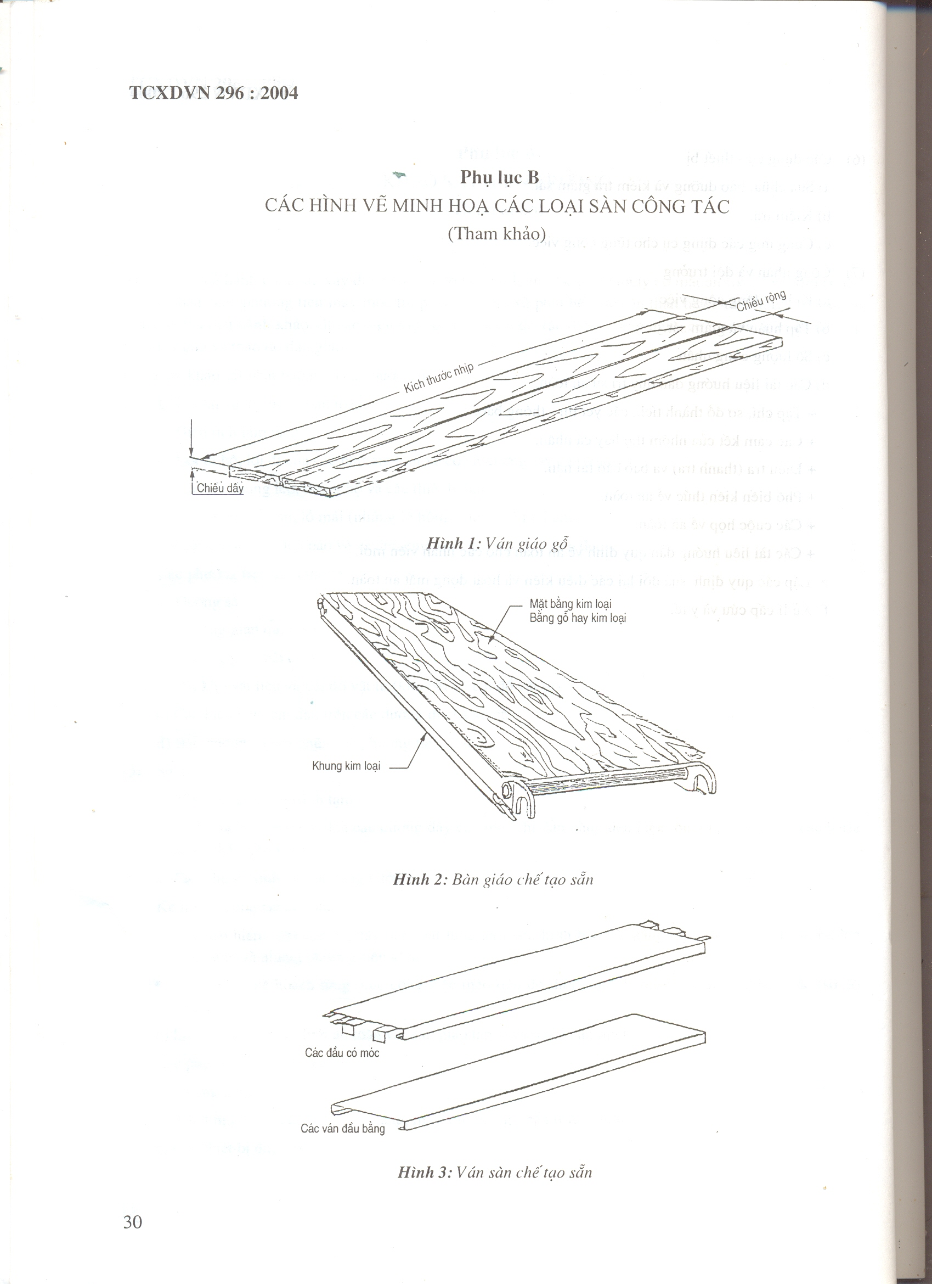

Handrail system
Figure 7 – Passing path in frame scaffolding [1]
Bold connection
Ladder side
Cross bar
Scaffolding frame feet
[Ready made]
Working floor
Handrail system
Cross bar
Figure 6 – Shaped beam floor
Max length 12.0 m
Max width 0.5 m
Max width 0.75 or 0.9 m
Max working load 200-300 [kg]

Max length 9.6 m
Max width 0.3 m
Max load 200 [kg]

Figure 5 – Wood floor board scaffolding
Max length 7.2m
Max width 0.3m
Max load 100 [kg]

Figure 4 – Wood frame floor board
Iron type
Wood type
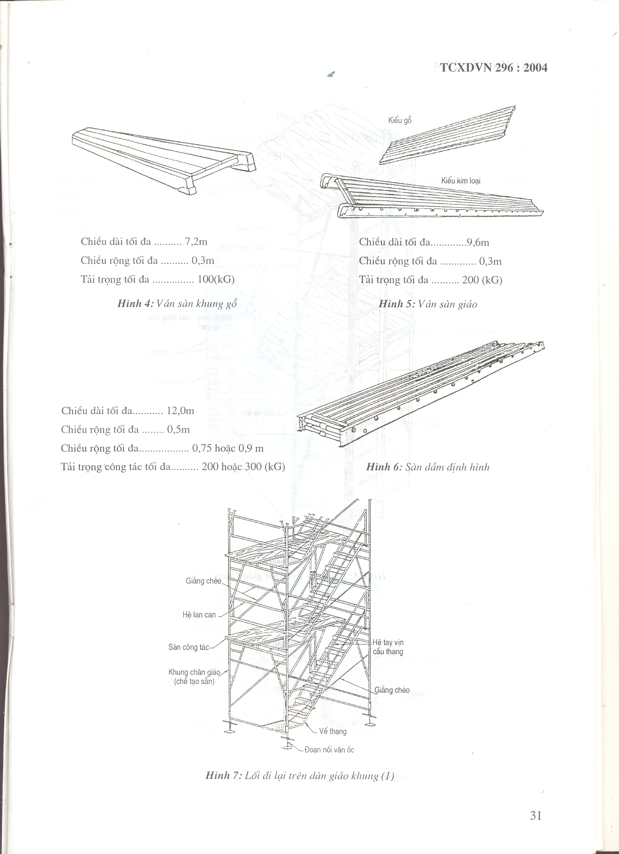
Down ladder
Lance frame
Working floor
Cross bar used as handrail system
Figure – Passing path in frame scaffolding
Connecting support s
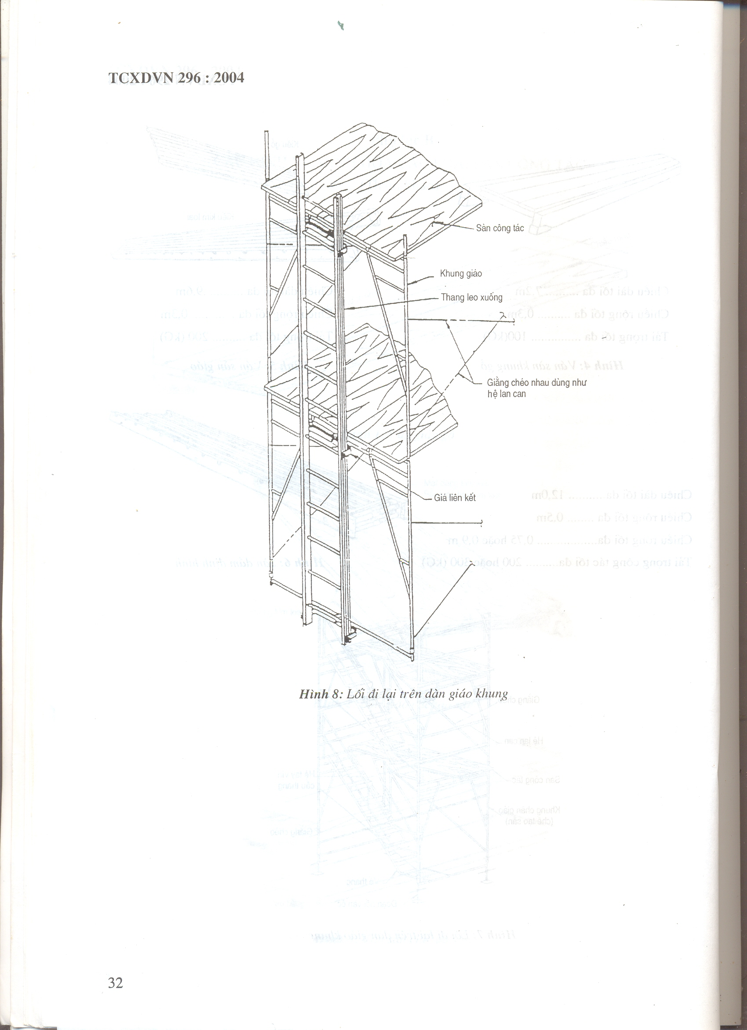
Figure 1 – Wood pillar scaffolding

Figure 2 –Scaffolding for builders-square feet
Cross bar from central frame
Connecting support s
Corner bar
Supporting leg
Horizontal support bar
Longitudinal bar
Cross bar
Climbing ladder
Handrail
Horizontal bar
Height levels of working floor
Pillar
APPENDIX C
SEVERAL SCAFFOLDINGS USED IN THIS STANDARD
[For reference only]

Figures from 1-31 are illustration for several common scaffoldings. Even just typical illustrations but they not limit in creating specific products, design or installation.
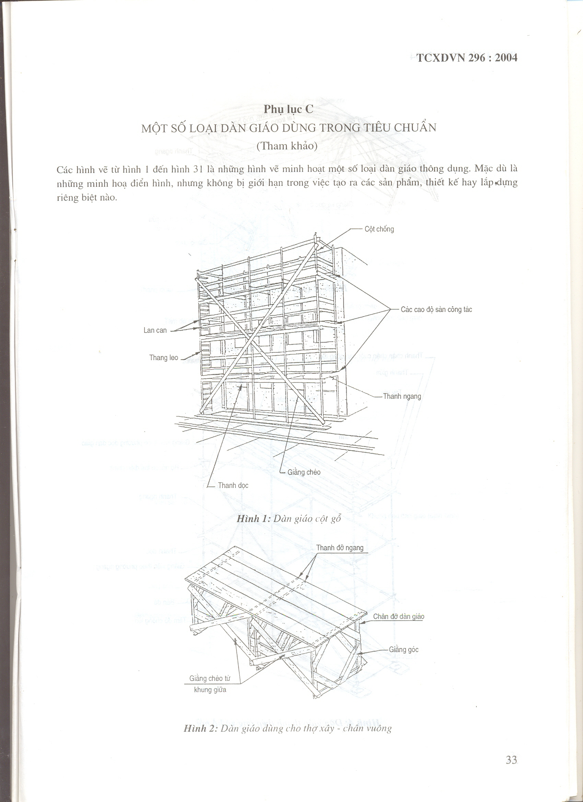
Cross bar
Longitudinal bar between supporting leg
Horizontal bar central frame
Light load, < 2.4 m
Medium load < 1.5 m
Top corner bar
Leg of scaffolding
Floor board
Central bar
Preventive bar for end leg of scaffolding
Handrail
Figure 4 – Steel pipe scaffolding and joint
Standard joint
Central bar of handrail
Figure 3 – Horse typed scaffolding
Cross bar
Adjustable joint
Cross bar per vertical scaffolding
Top bar –Handrail
Longitudinal bar
Cross bar per horizontal direction
Stand
Anti-sinking plate
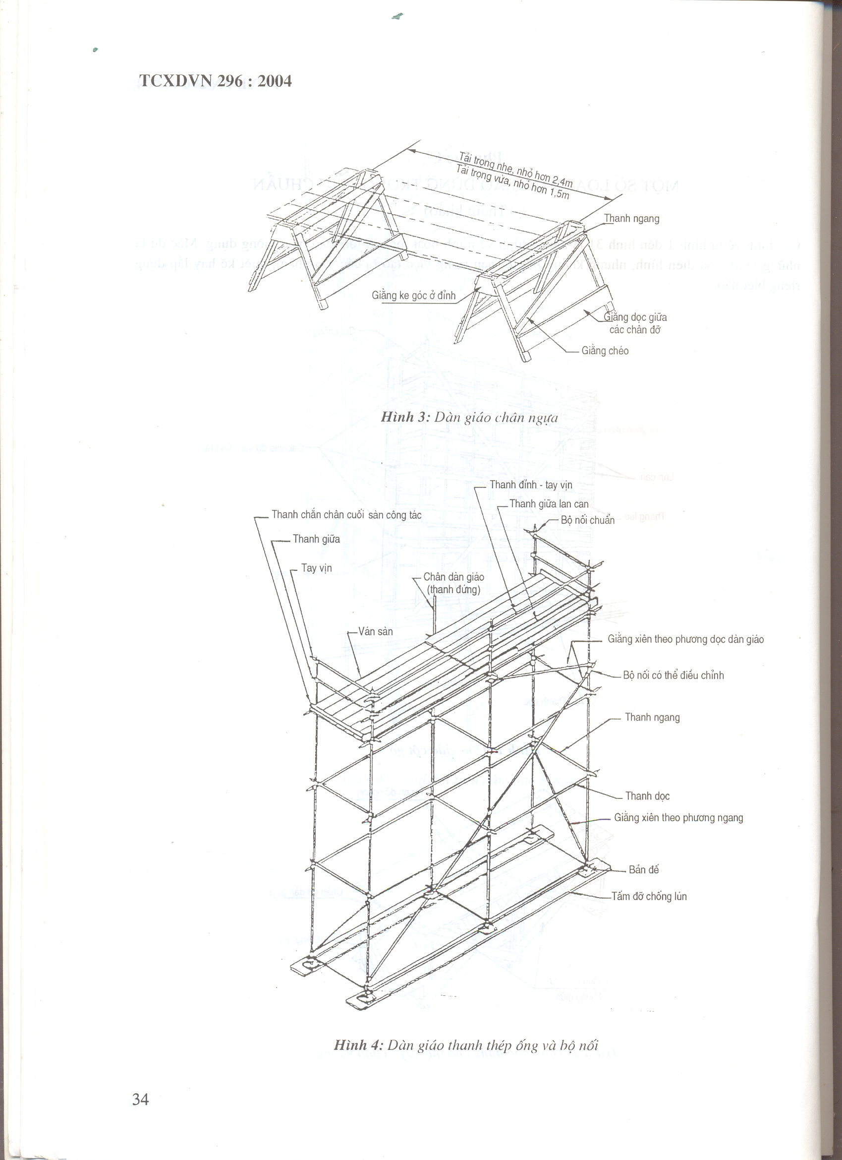
Cross bar
Bold connector
Horizontal bar
Wood floor
Cantilever
Crossbar
Adjustable stand
Figure 6 – Readymade steel pipe scaffolding
Crew
End frame of scaffolding (fixed)
Handrail system
Horizontal bar along scaffolding
Fixed connector
Connections
Figure 5 – Scaffolding unit/steel pipe and joints
Anti-sinking plate
Passing ladder
Handrail
Rest floor
Screw joint
Independent vertical bar
Working floor
Handrail system
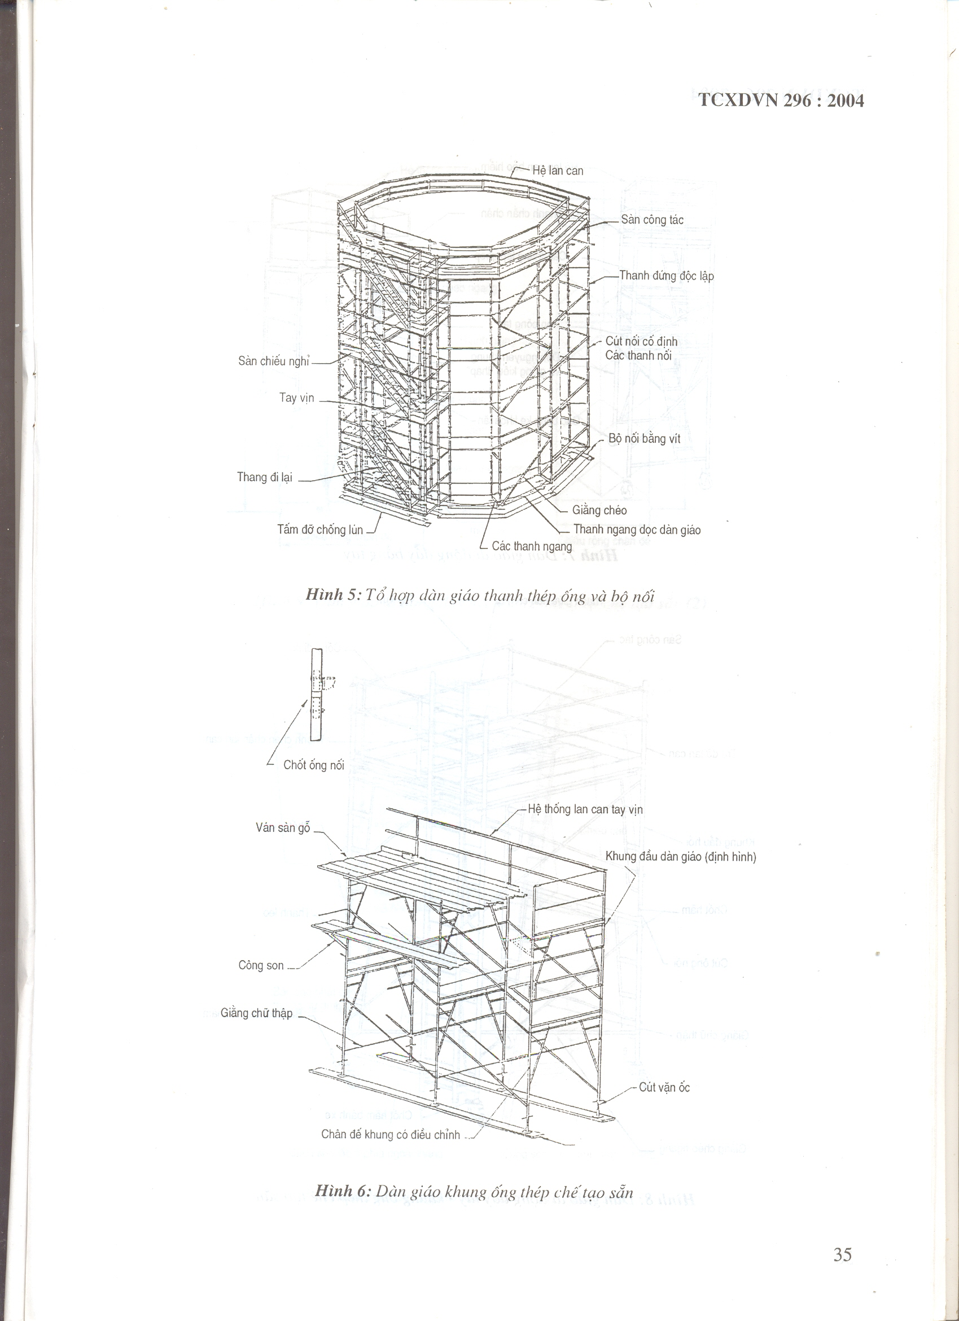
Wheel brake
Wheel brake
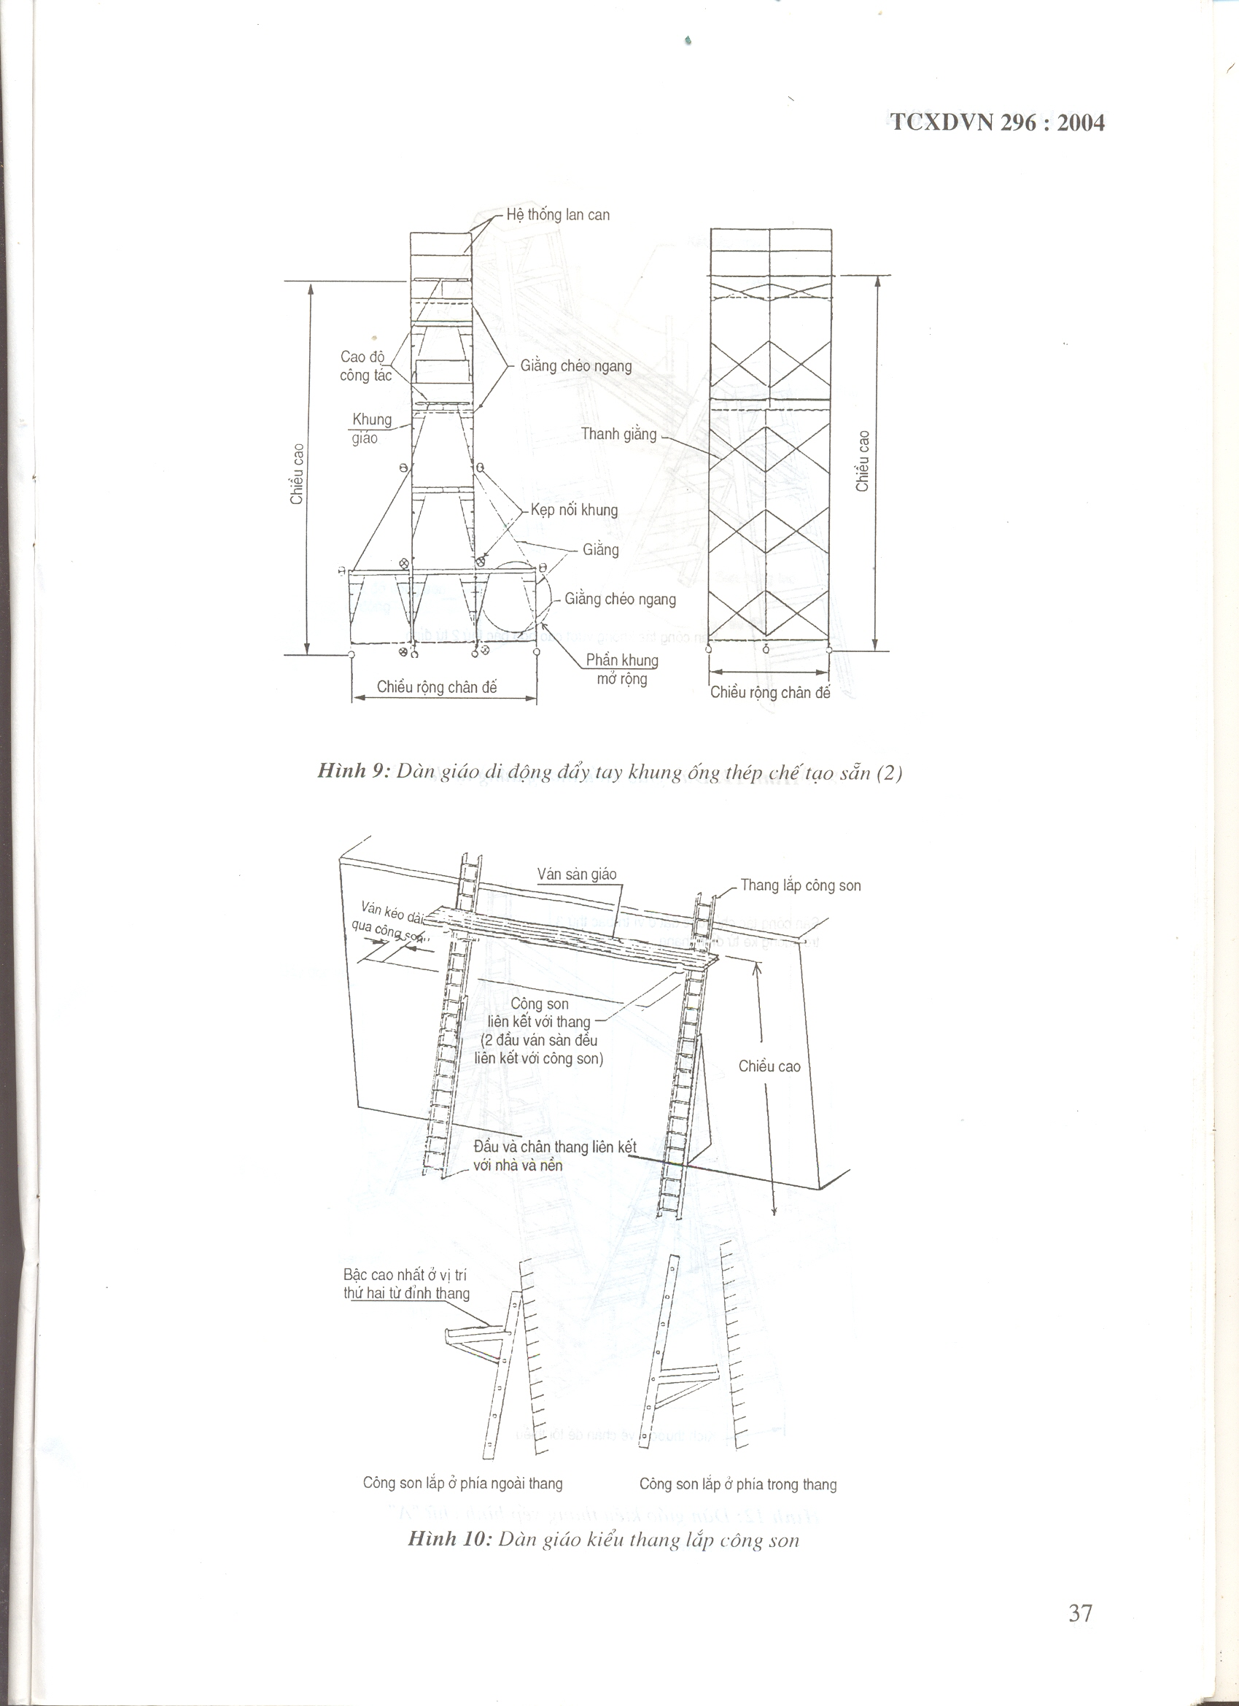
Wheel brake
Figure 8 – Manual mobile scaffolding – Ready made steel pipe frame
Horizontal cross bar
Lockable wheels
Main frame and “tower” bar
Working floor
Assembly stair
Leg protective bar
Working floor

Climbing ladder
Brake wheel
Connector
Cross
Brake bolt
End frame
Pillar
Banister
Central bar
Handrail
Banister bar
Passing path
Clock bolt
Figure 7– Manual mobile scaffolding
Security handrail
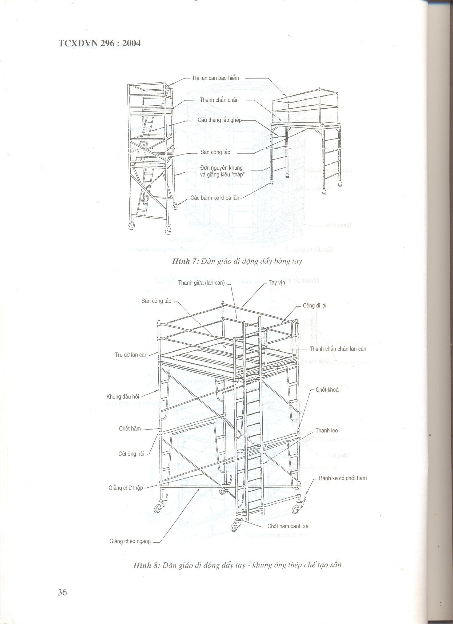
Cantilever assembled inside scaffolding
Cantilever assembled outside the ladder
Highest step at 2nd position from ladder top
Ladder head and led connected with floor
Height

Cantilever connecting with ladder [2 sides of floor board connected herewith]
Cantilever prolonged board
Cantilever ladder
Frame
Working height
Horizontal cross bar
Horizontal cross bar

Figure 9 – Manual mobile scaffolding /Ready made steel pipe [2]
Figure 10 – Cantilever ladder typed scaffolding
Stand width
Stand width
Frame
Extent

Bar
Frame clamp
Cross bar
Banister system
Lance board floor
Wheel brake
Working floor placed only within the 3rd position downward from ladder top

Size from 1 side of min stand leg
Wheel brake
Figure 12 – A ladder type scaffolding
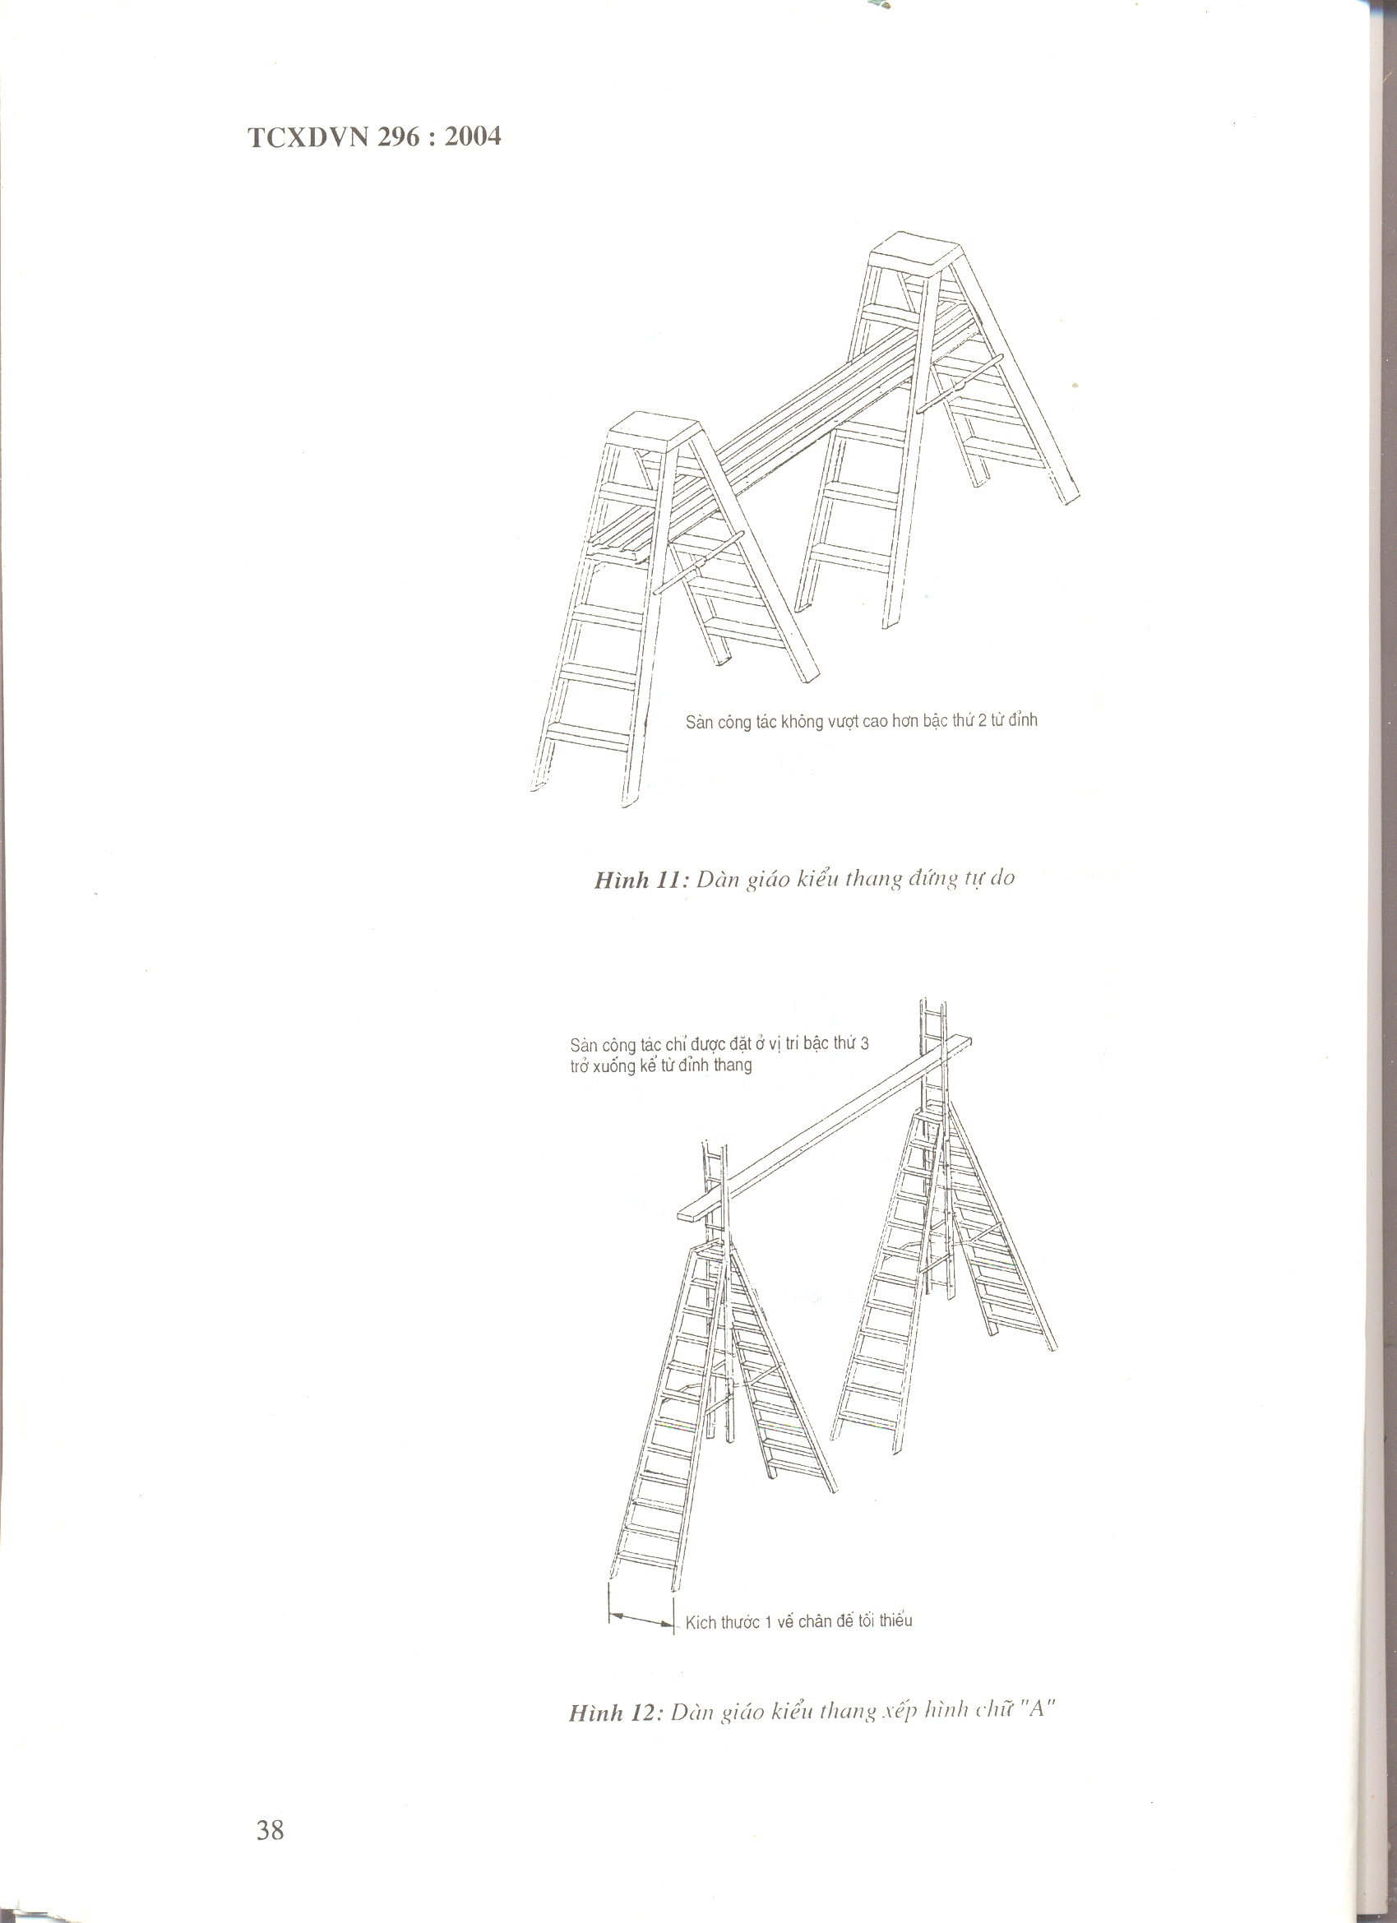
Figure 11 – Vertical free ladder typed scaffolding
Working floor not exceed 2nd step from top
Figure 14 – multi-suspended scaffolding
Lifting floor
Lance floor
Lifting cable
Figure 13 – Pillar scaffolding and mobile cantilever supporting scaffolding
Banister system
Independent cable
Mobile cantilever support
Building structure
Cross bar
Sub-working floor
Working floor
Pillars
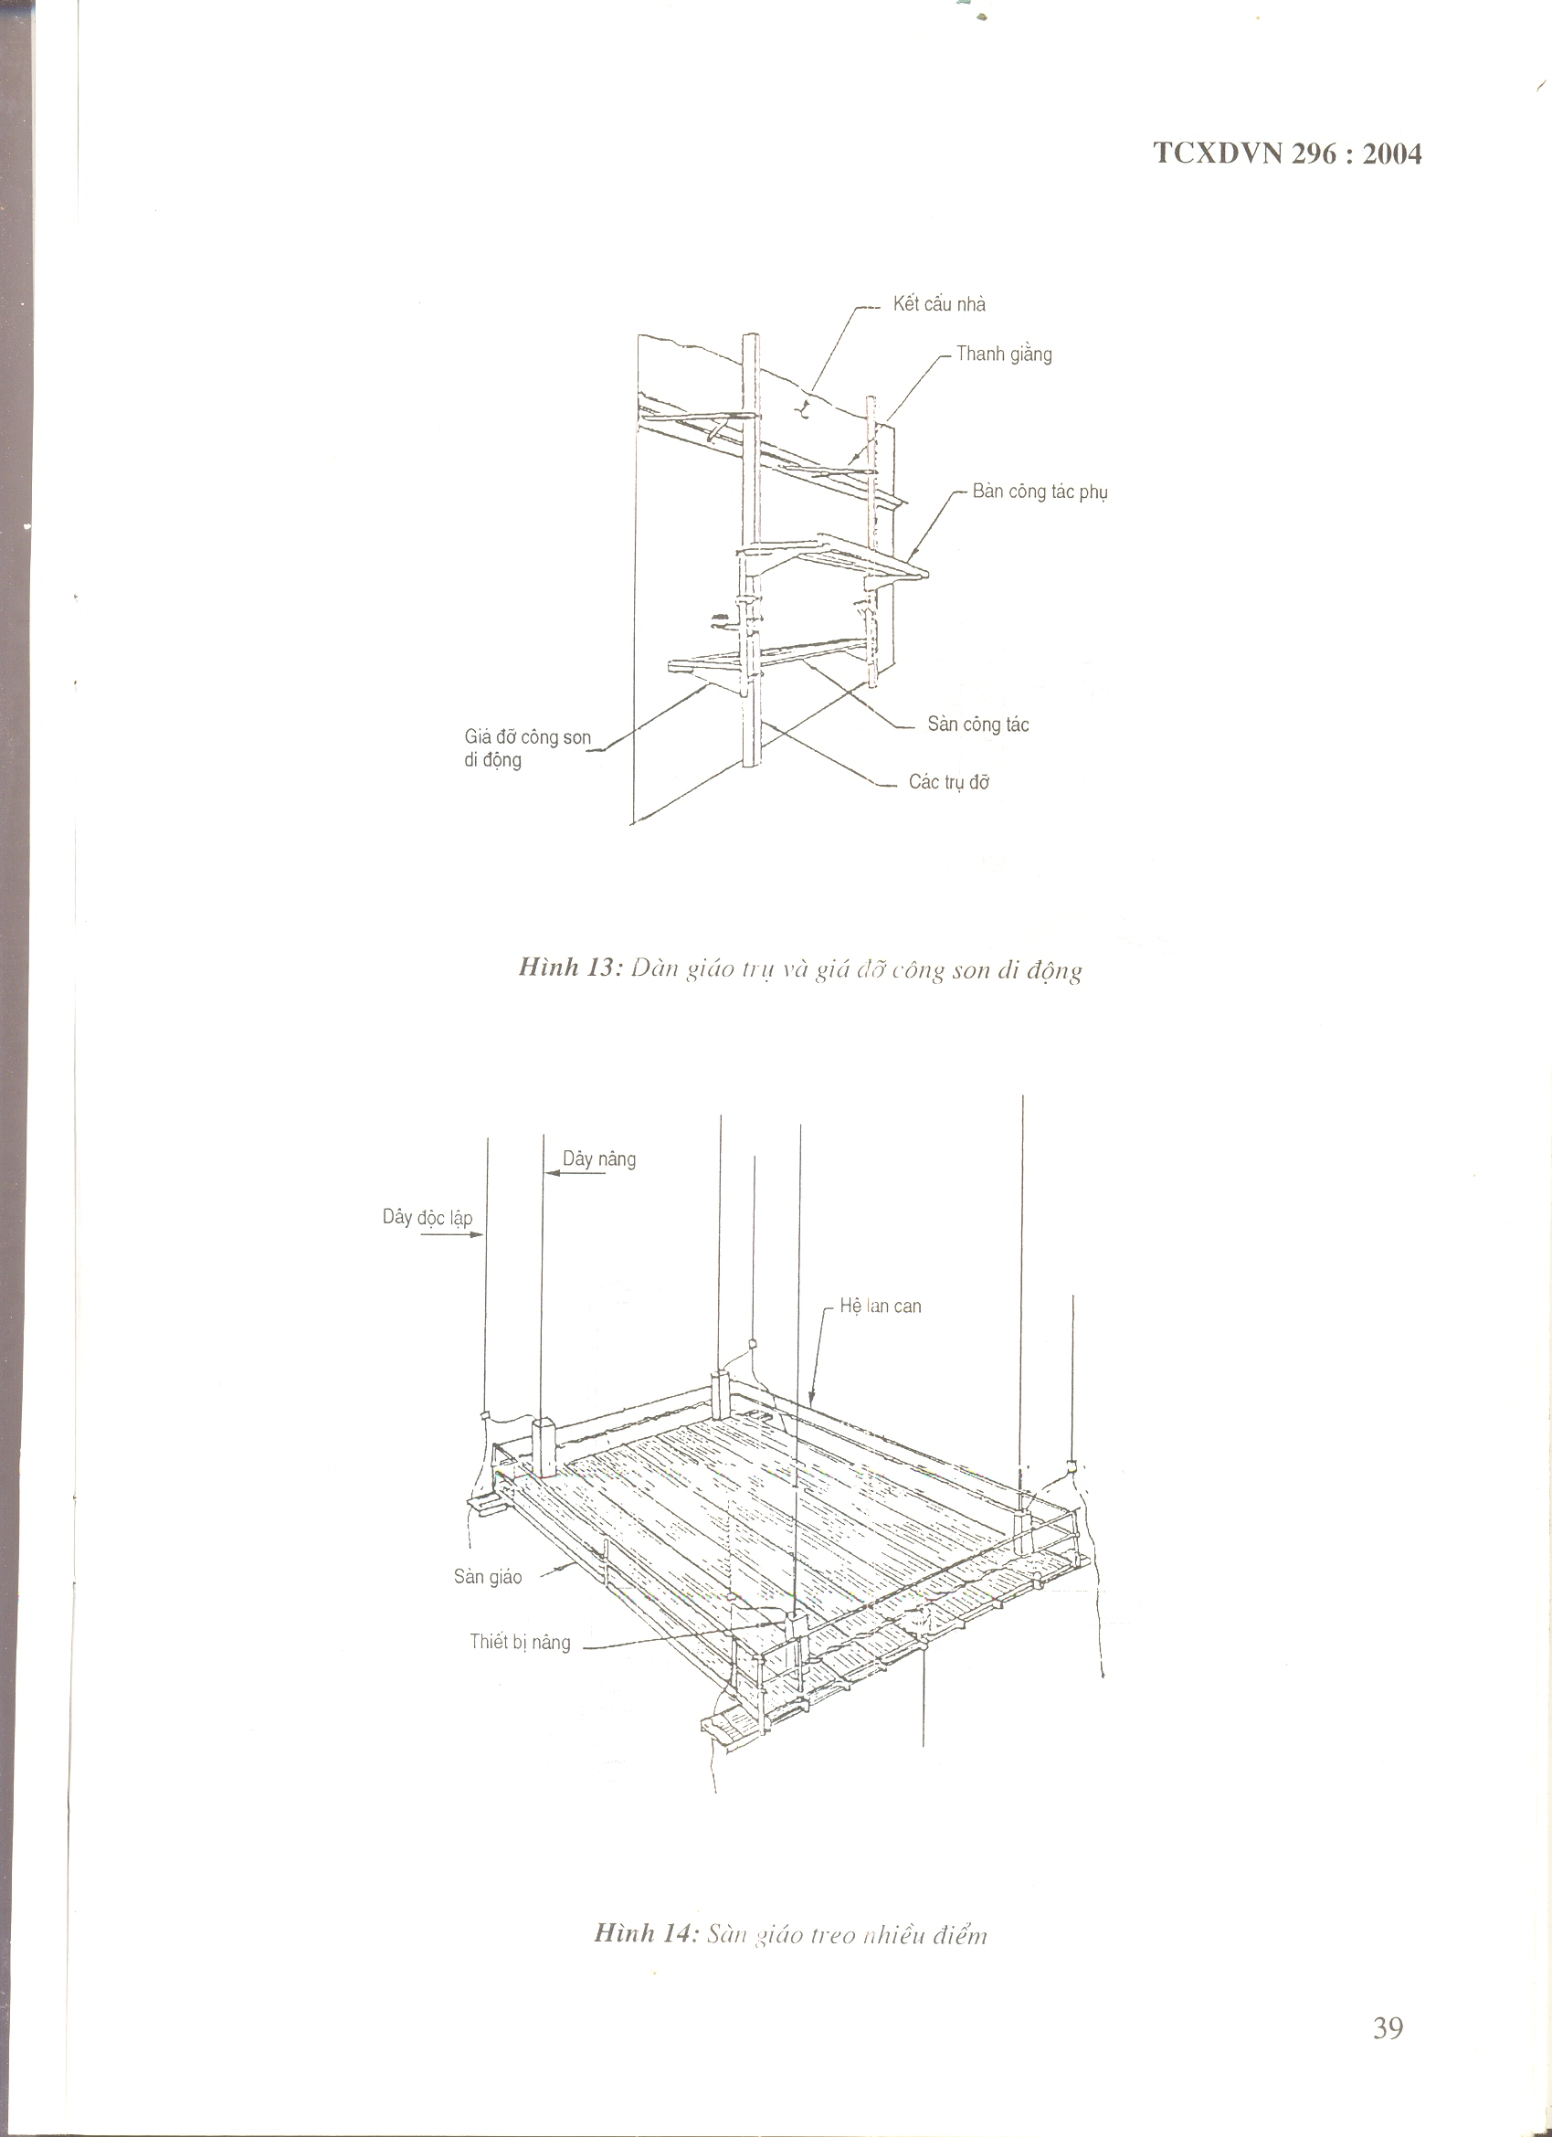

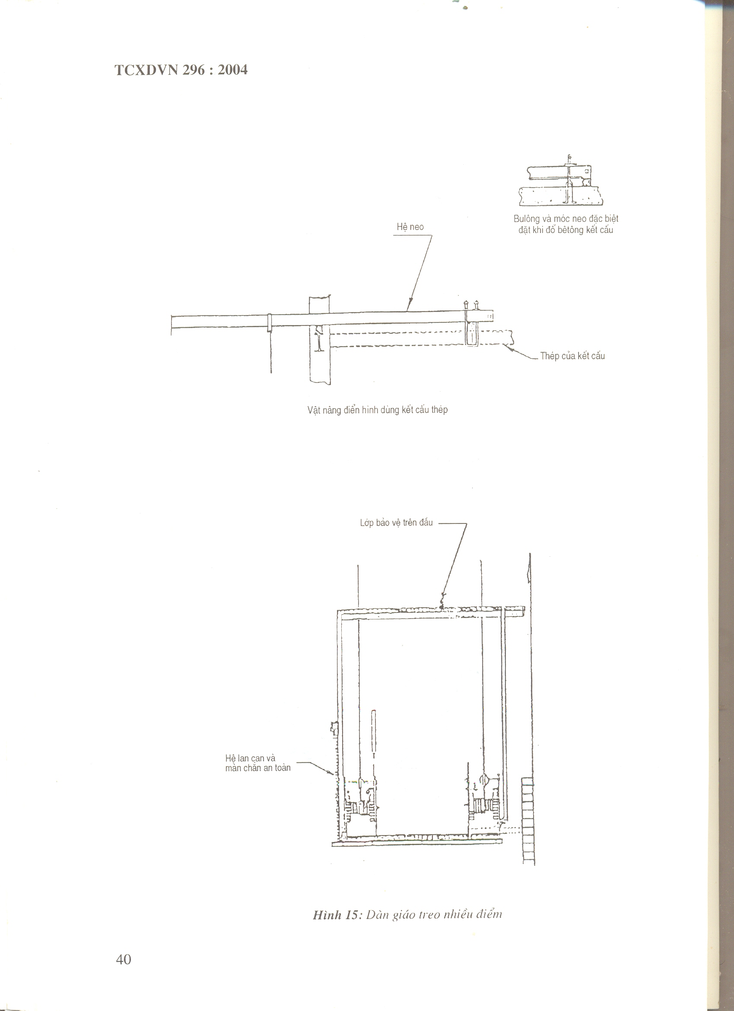
Banister system and safety curtain
Overhead protective layer
Steel of structure
Figure 15 – Multi-suspended scaffolding
Special bold and anchor hook placed on filling cement concrete
Anchor system
Typical lifting equipment that use steel structure
Figure 16– 2 point suspended scaffolding with electric pulling lifting equipment
Wood block clock
Redundant cable to roll up tied at 3 point to prevent from loosen
Rear anchor must have durability equivalent with pulley firmly connected with main force bearing of work

Cantilever beam
Floor board
Wood block
Counterpoise
Rear anchor
3 clamp retaining cables
Rear anchor
3 clamps
Counterpoise lay beneath the cantilever over the roof wall horizontally
Corner protective mattress
Rear anchor wire
Typical counterpoise support used in case of high roof wall
Technical hard wood lob 90 x 10 x 30 cm with hole to place bold ‘U”
Items of “U” bolt
Rear banister system
Front banister system [if required]
Iron heavy load bearing
3 clamps retaining cable
Lead to machine
Beneath free head of cable
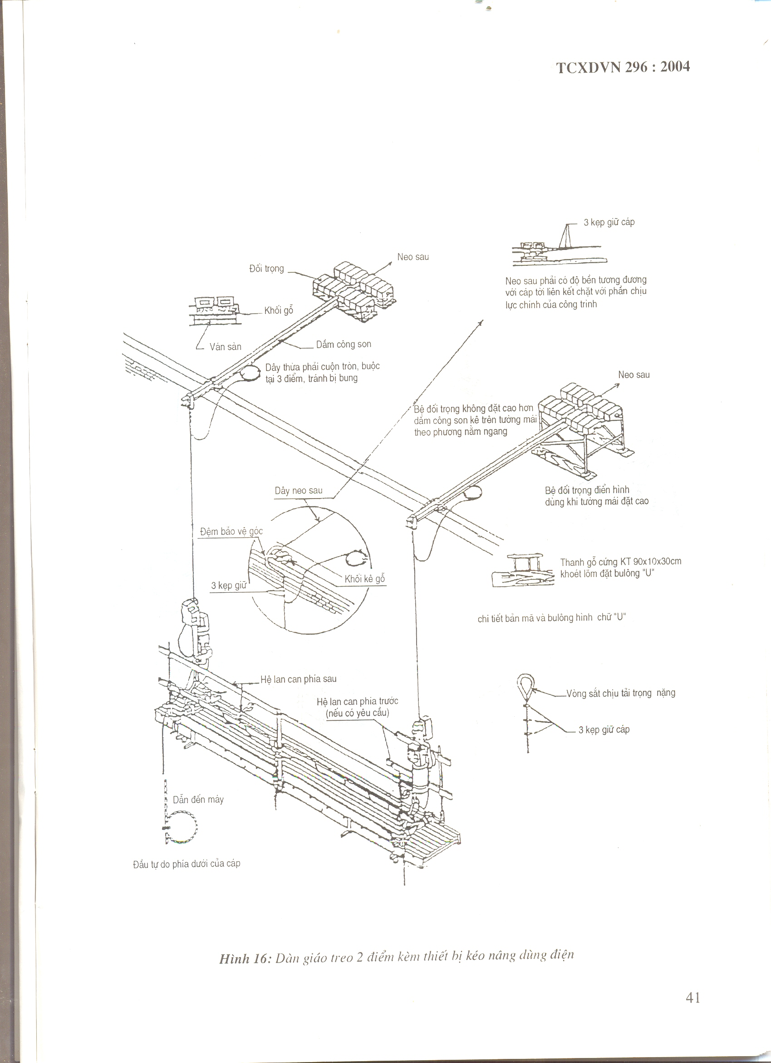
Rear anchor
Rear bolt connection
Rear anchor connection
Cantilever crane
Hanging wire
Working floor
Figure 17 – 2 point suspended scaffolding with winching and lifting - electric use
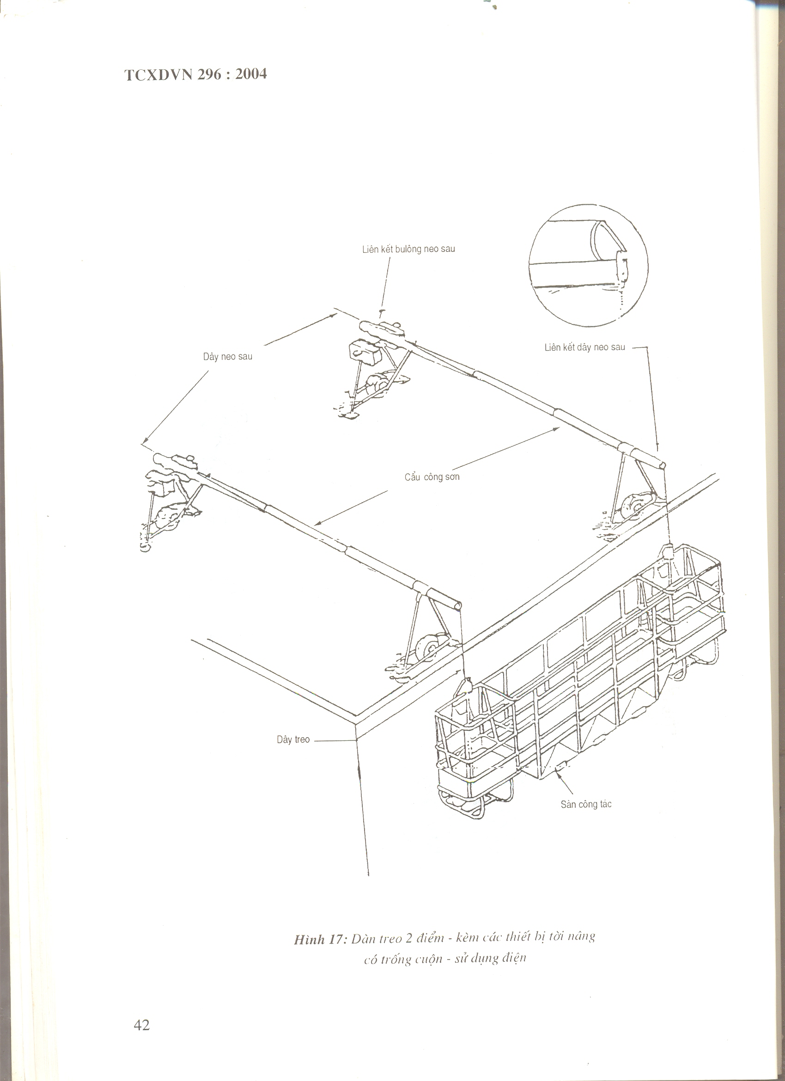
Positioning anchor point with max distance = 1.2m
Lifting equipment with manual wire winching
Wheel
Anchor bar
Winching, lifting wire
Rear and front banister
Aluminum or wood working floor
Figure 18 – 2 point suspended scaffolding, manually operated
Anchor to roof
Rear anchor
Cantilever beam
Heavy load hook
Cable holder
Building structure
Adjustable crane to keep the scaffolding stable
Directional guiding cable
Earth contact anchor
Figure 19 – 2 point suspended scaffolding with oscillation by earth anchor
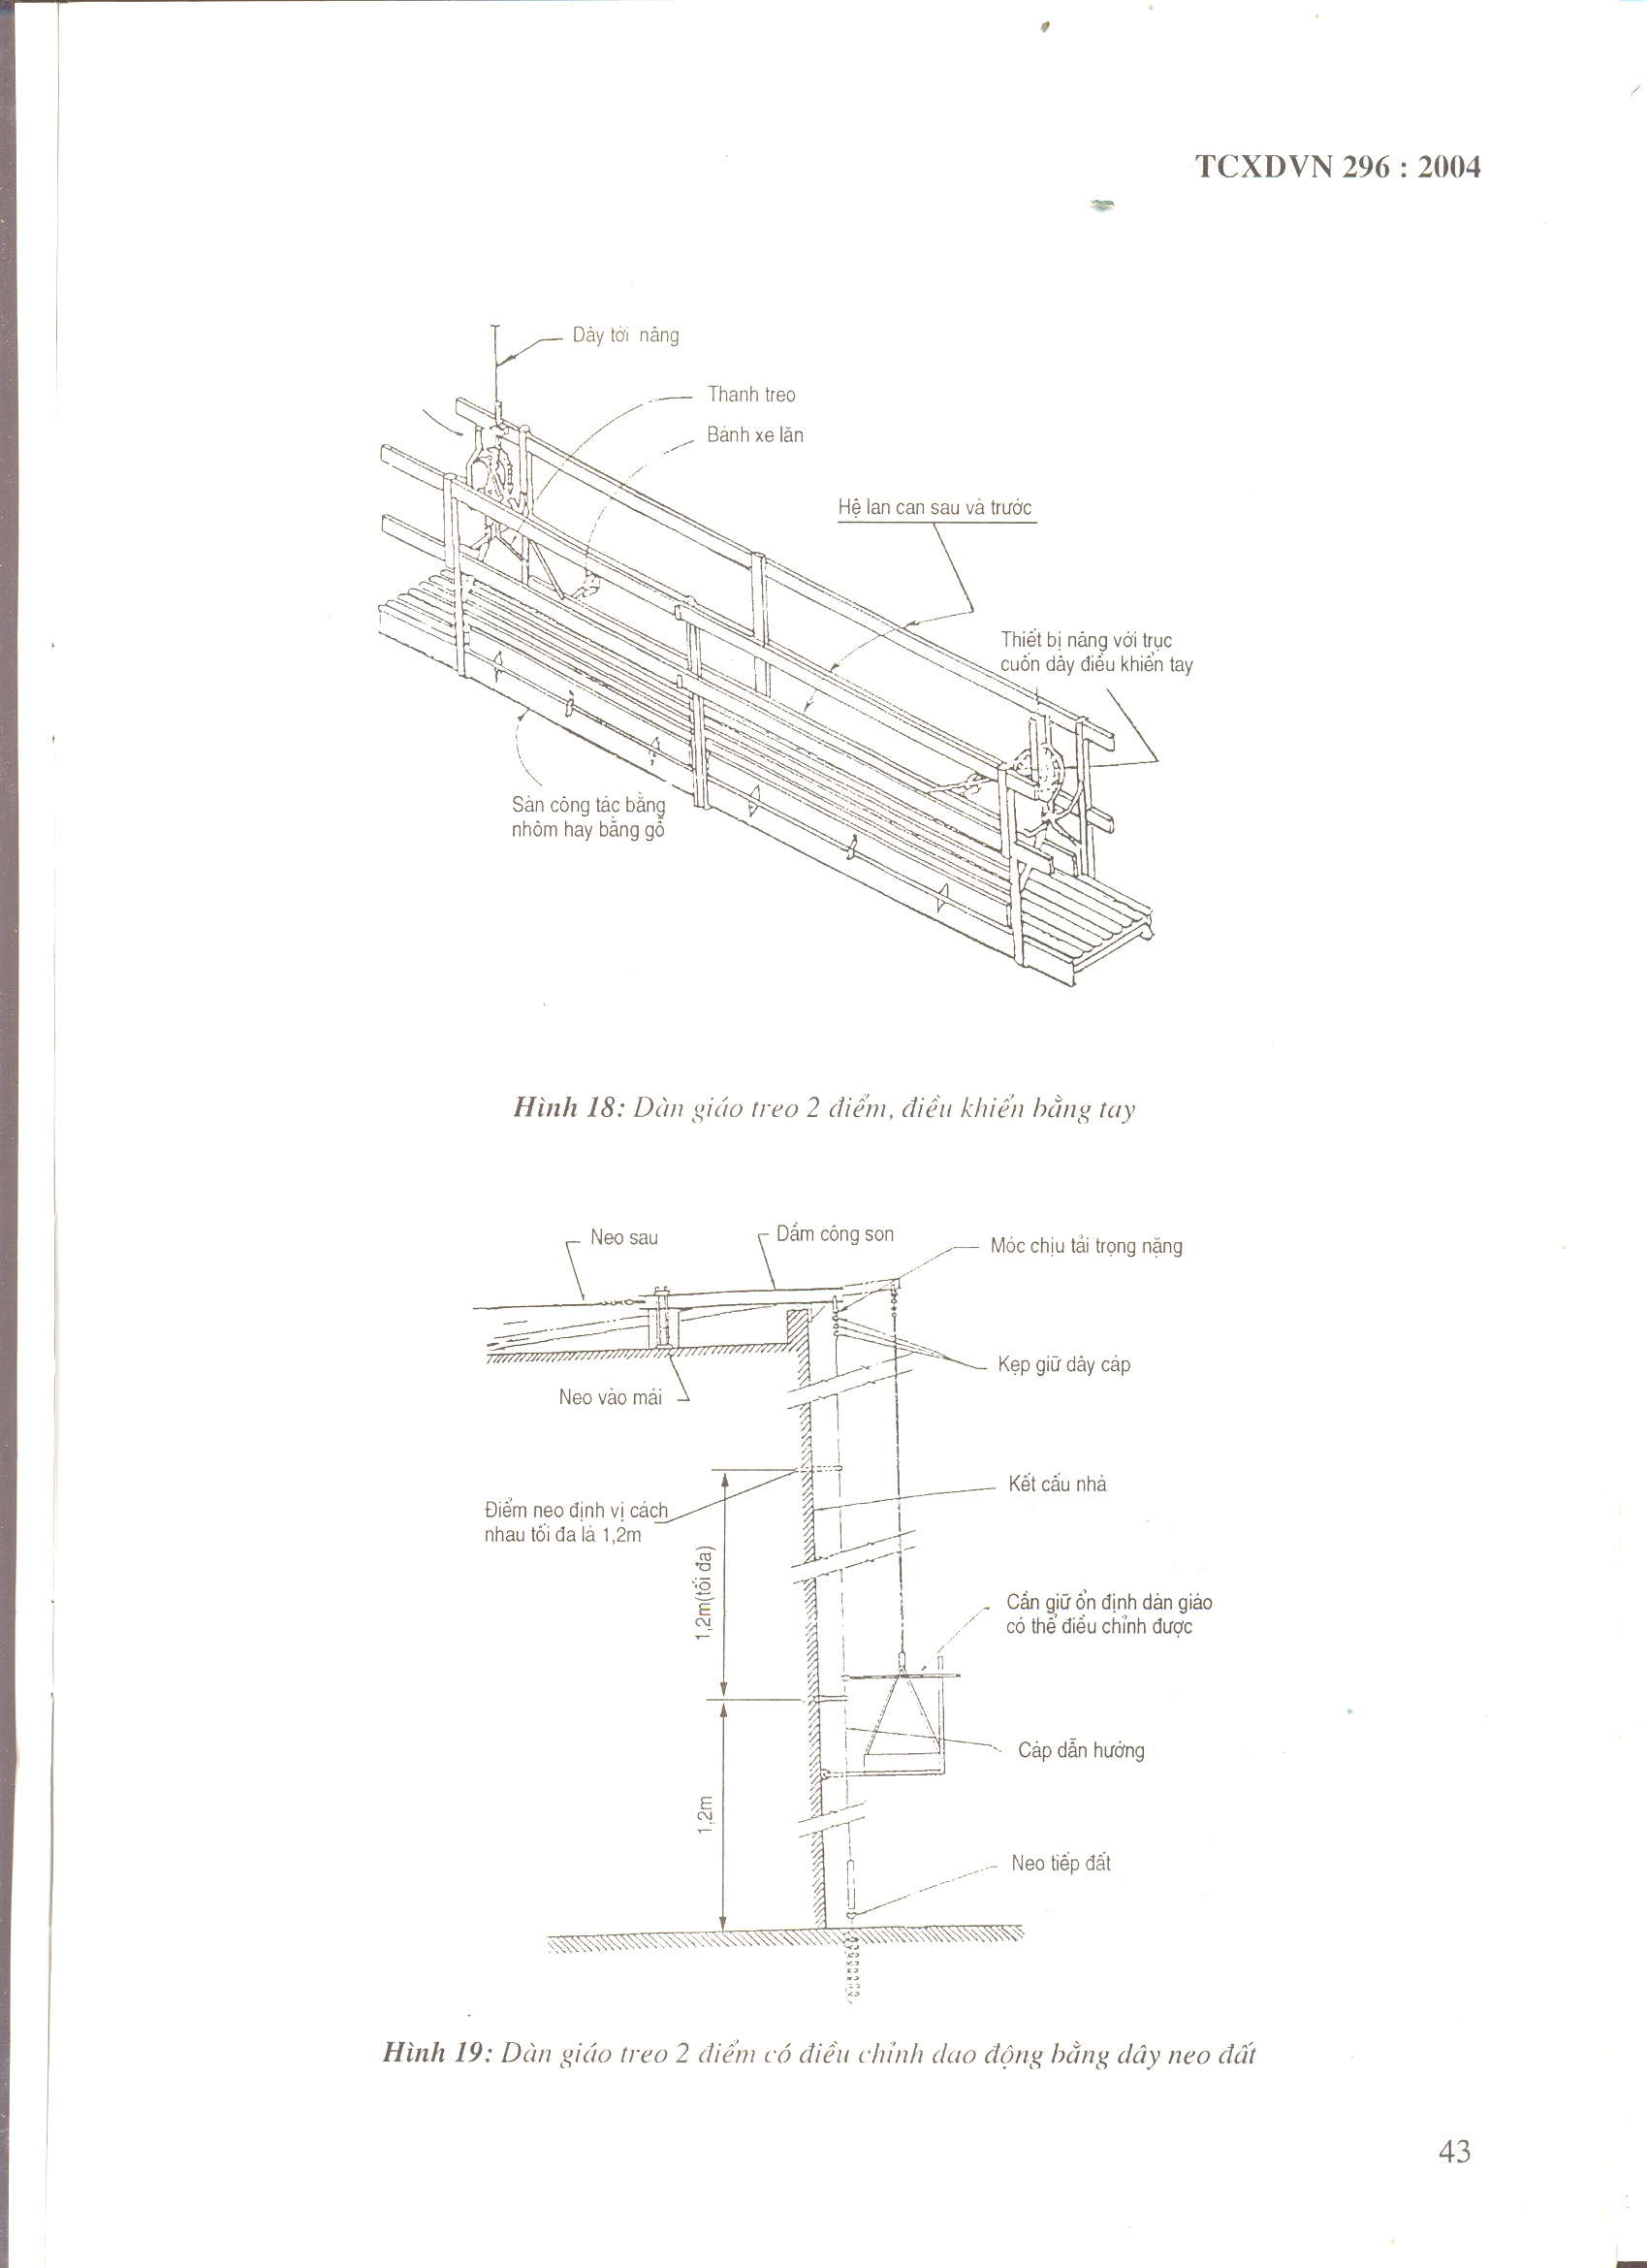
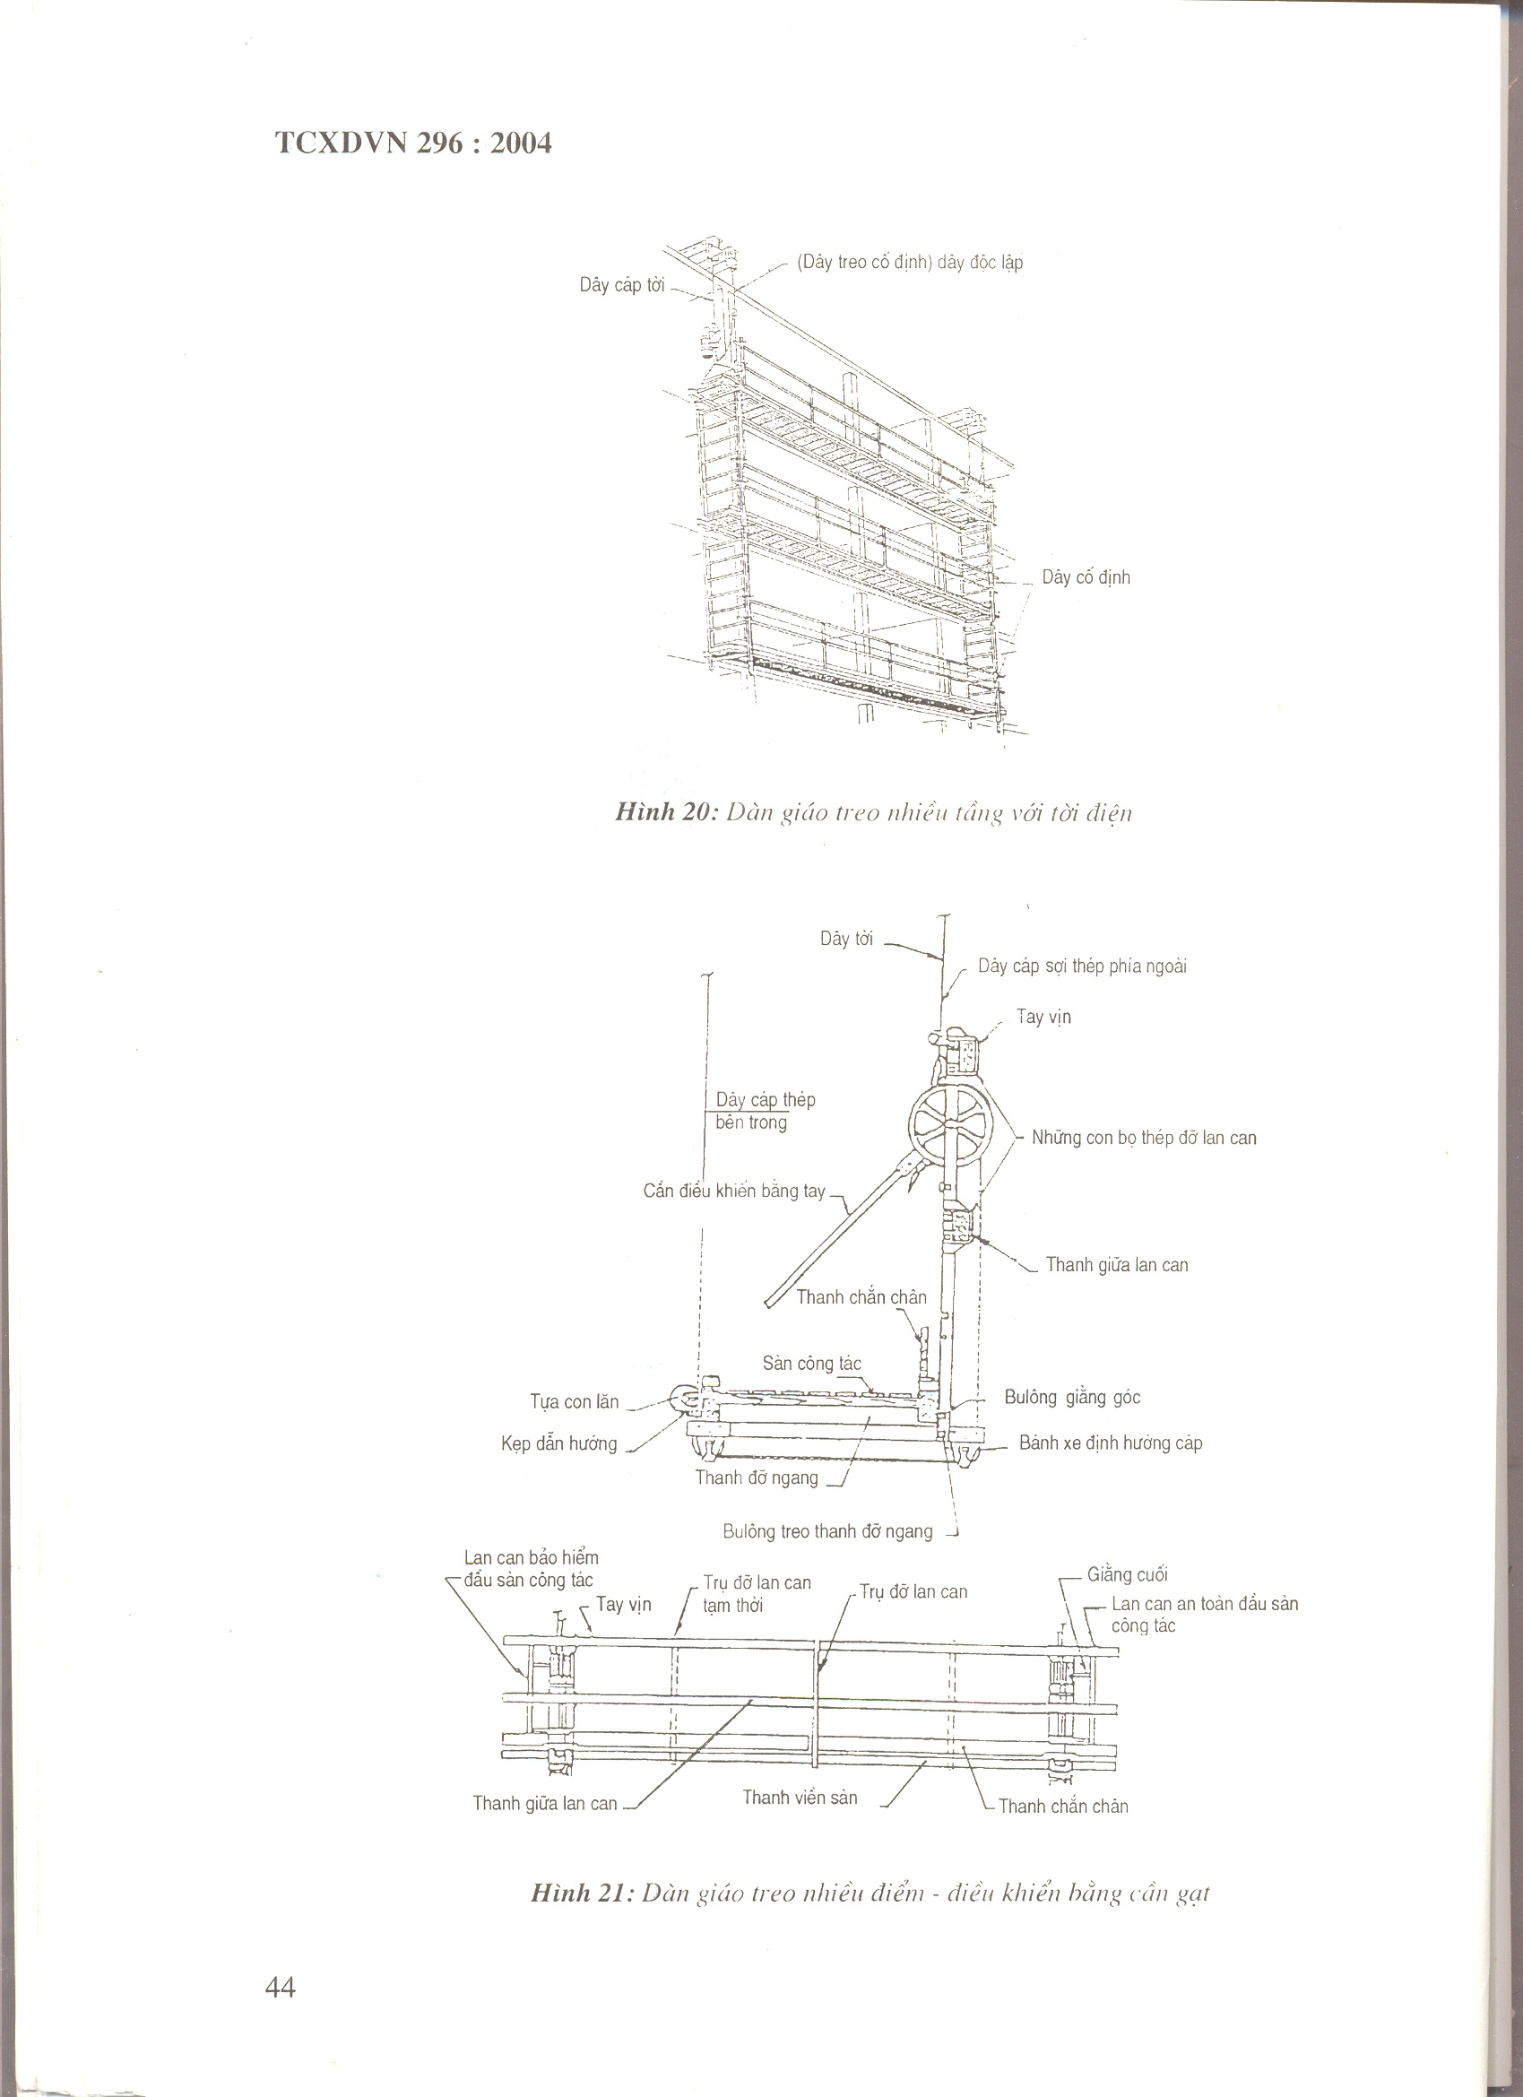

[Fixed suspended wire] separated wire
Winching cable

Fixed wire

Figure 20 – Multi-suspended scaffolding with electric winch

Winching wire
Outer steel cable

Handrail
Inner steel cable
Banister supporting steel bugs
Manual control crane

Central banister bar
Leg protective bar
Working floor
Roller stand
Corner bar bolt

Horizontal support bar
Directing clamp
Cable directing wheel
Bolt for suspending horizontal bar
Safeguard banister at head of working floor
Temporary banister pillar
End bar
Handrail
Banister pillar
Safety banister at head of working floor

Central bar of banister
Edge floor bar
Leg protection bar

Figure 21 – multi-suspended scaffolding – lever control
Figure 22 – one point suspended scaffolding with electric winch
Figure 23 – One point suspended scaffolding with drum winch
Separated wire
Winching wire
Separated wire
Winching lift wire
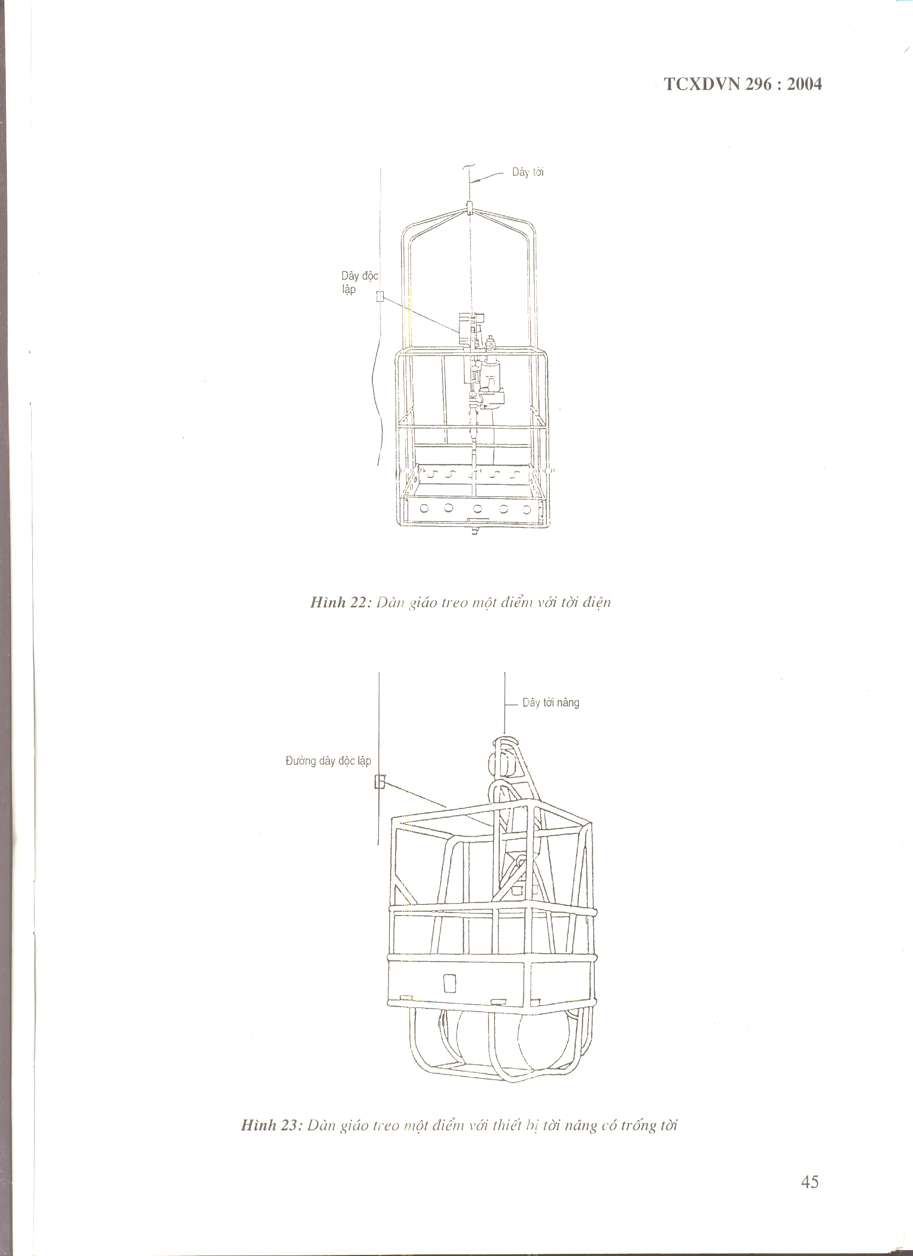
Figure 25: Suspended scaffolding. Indirect hook
Bake hook
Anchor
Anchor
Steel wires
Working floor
Vertical suspended wire
Upper stand surface
Figure 24 - Chair – Controller [electric]
Electric winch equipment
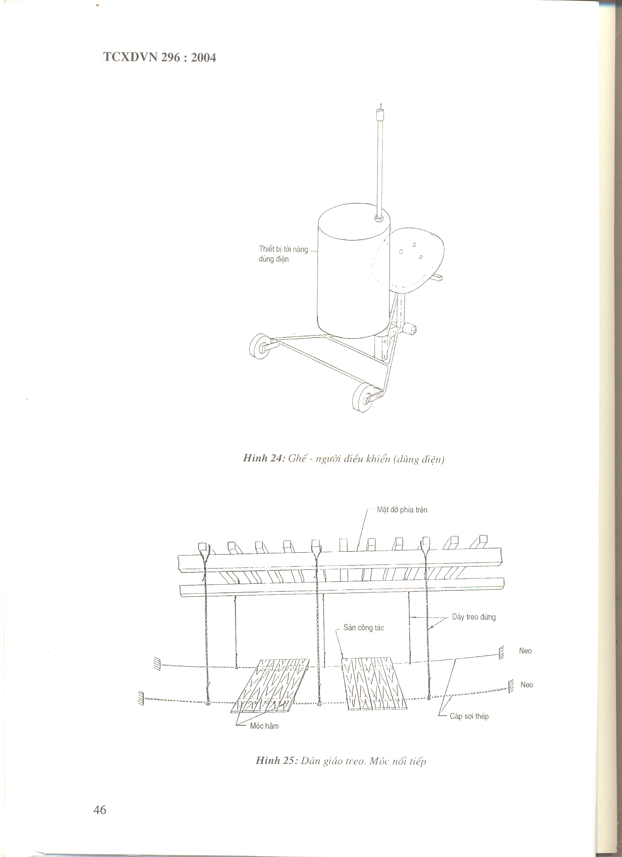
Figure 28: 4 no shaped scaffolding
Figure 27 – Cantilever beam scaffolding
Figure 26: Suspended beam scaffolding
Working floor
Cable
Suspended beam
Tightening point
Pillar system
Work
Leg protective bar
Handrail
Cantilever beam
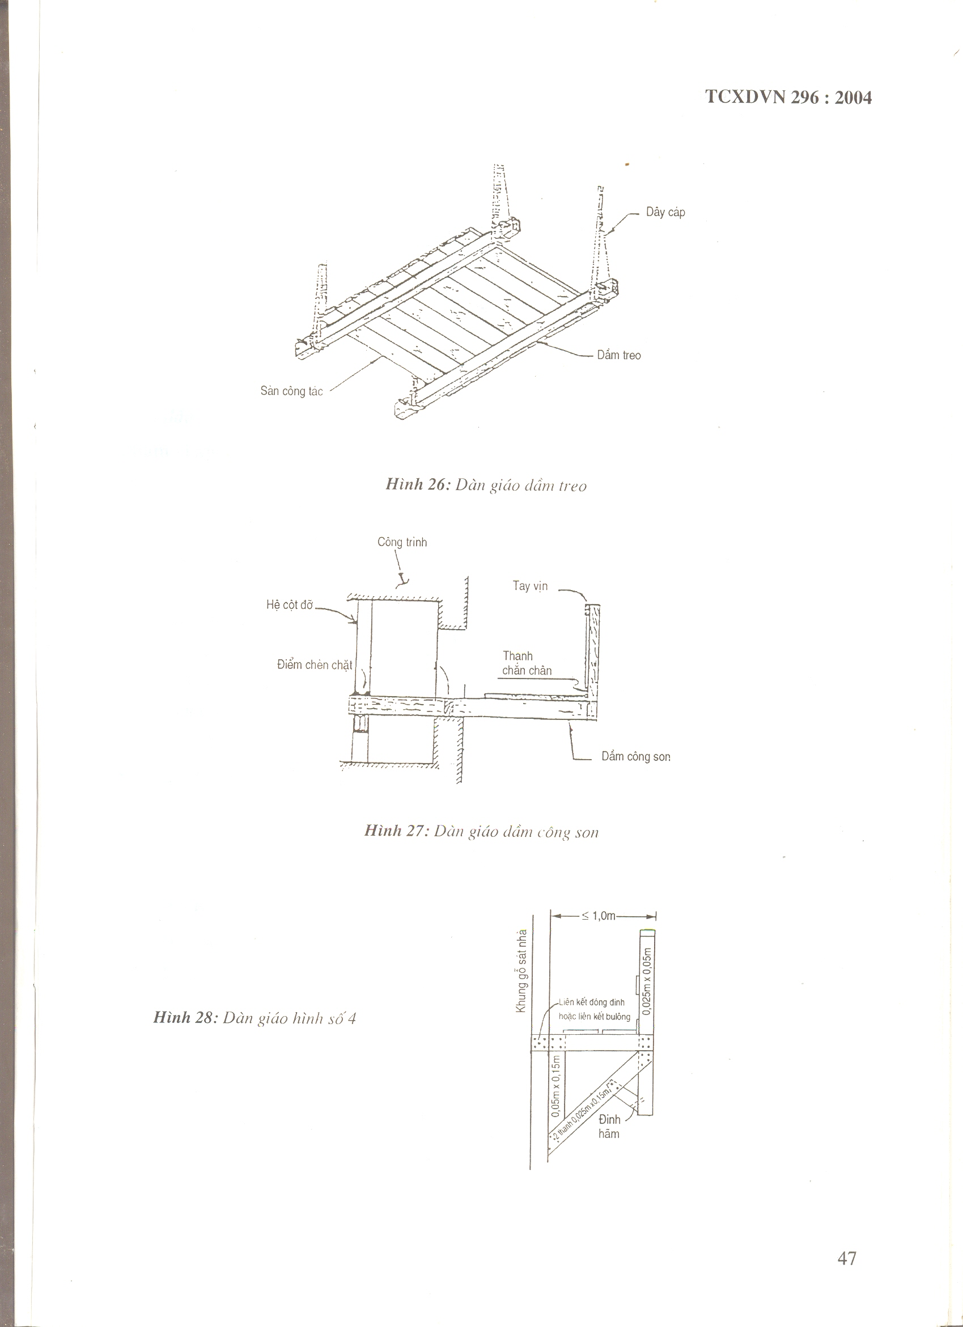
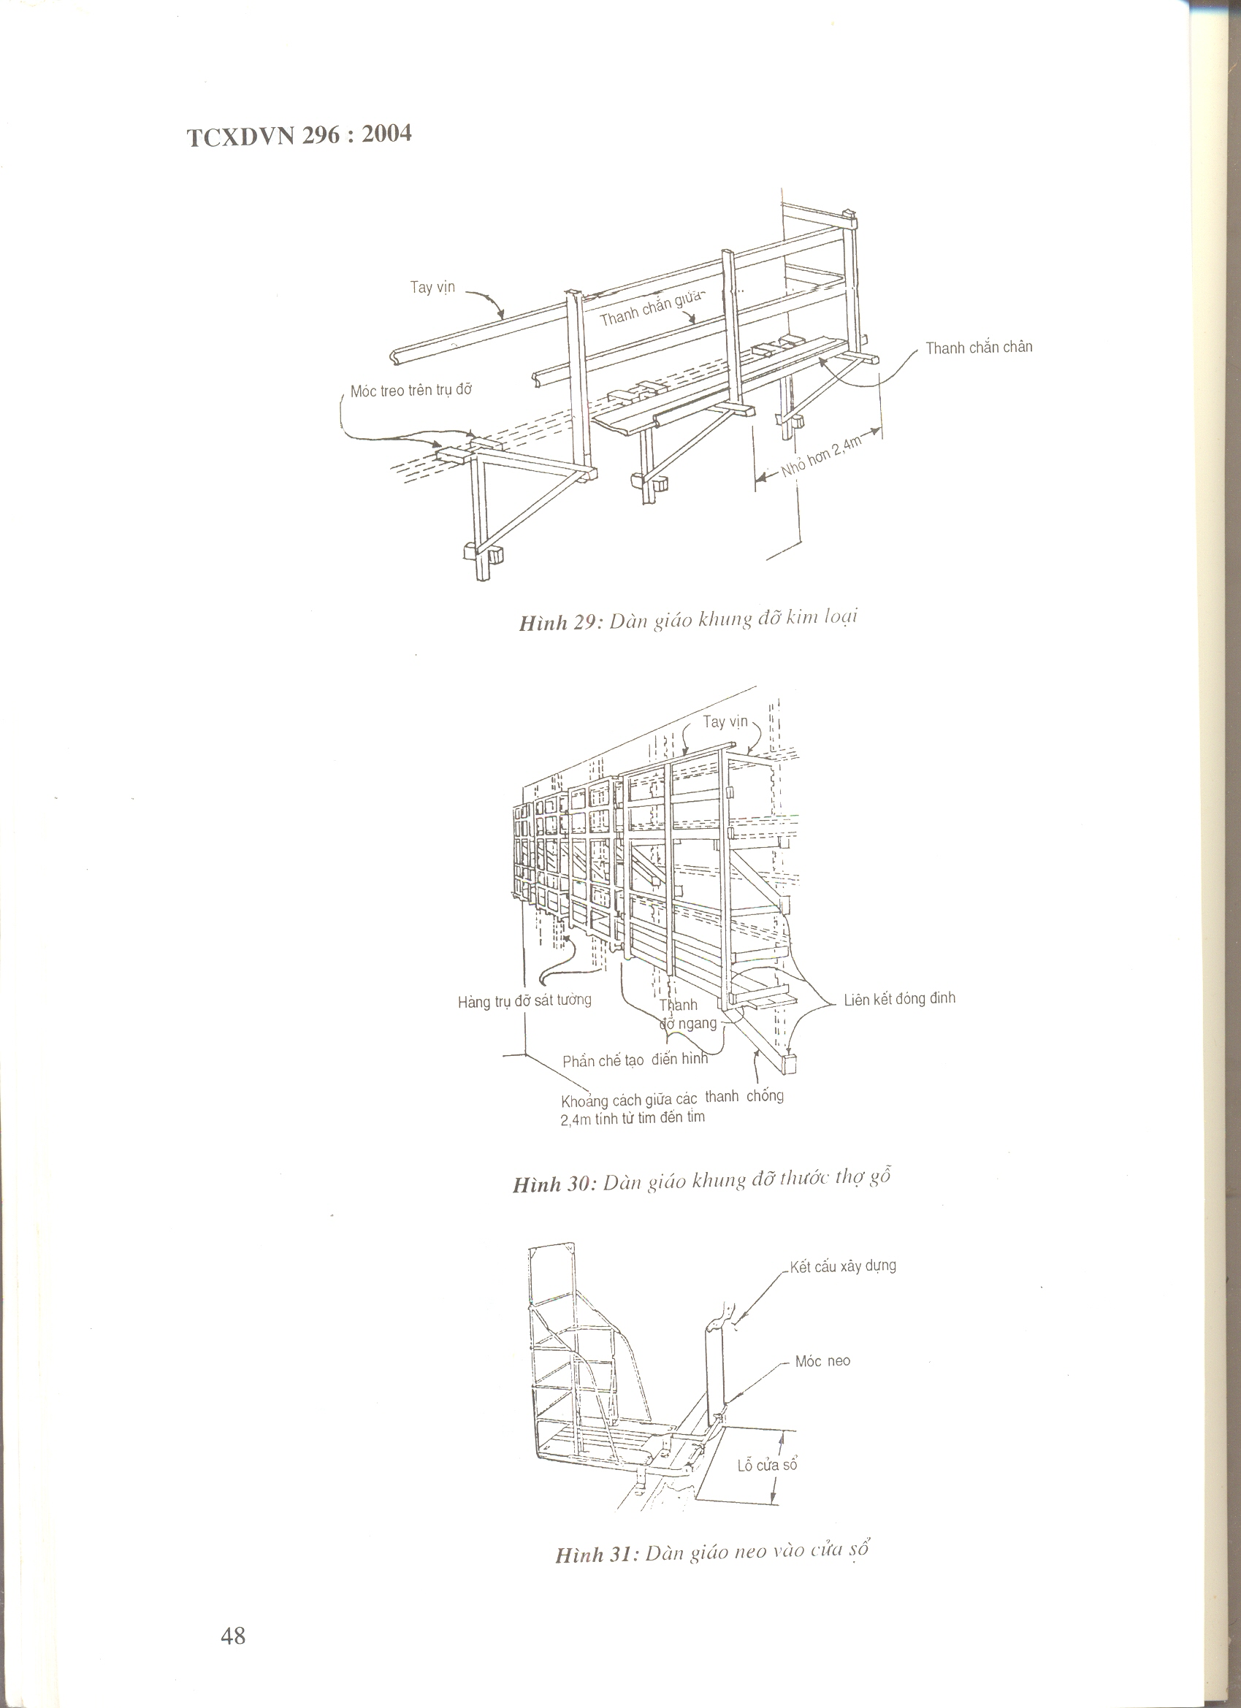

Figure 31: Scaffolding anchored to windows
Supporting column close to wall
Distance from pillar = 2.4 m from center to center
Leg protective bar
Central protective bar
Suspended hook on stand
Handrail
Figure 29 – Iron stand scaffolding
Nail connection
Figure 30: Geometrical typed Stand scaffolding
Building structure
Anchor hook
Windows

